Supplementary material

The role of intense-rainstorm-driven turbidity currents in shaping lacustrine paleoflood records

Gaétan Sauter¹, Damien Bouffard^{2,3}, François Mettra⁴, Koen Blanckaert⁵, Stefano C. Fabbri^{1,6}, Flavio S. Anselmetti¹, Michael Hilbe¹, Mathurin D. Wamba¹, Adrianus Damanik^{1,7}, Hendrik Vogel¹, Katrina Kremer^{1,8}

¹Institute of Geological Sciences, University of Bern, Oeschger Centre for Climate Change Research, Baltzerstrasse 1+3, CH-3012 Bern, Switzerland.
²Department of Surface Waters - Research and Management, Swiss Federal
Institute of Aquatic Science and Technology, 6047 Kastanienbaum, Switzerland.
³Faculty of Geosciences and Environment, Institute of Earth Surface Dynamics, University of Lausanne, 1015 Lausanne, Switzerland
⁴Institute of Energy and Environment, School of Engineering, HES-SO Valais-Wallis, Sion, Switzerland
⁵TU WIEN Research Unit Hydraulic Engineering and Environmental Hydromechanics, Vienna, Austria
⁶Federal Office of Topography Swisstopo, Seftigenstrasse 264, 3084 Wabern, Switzerland
⁷Research Center for Climate and Atmosphere, National Research and Innnovation Agency (BRIN), Bandung, Indonesia
⁸Swiss Seismological Service, ETH Zurich, Sonneggstrasse 5, CH-8092 Zurich, Switzerland

Author Note
Gaétan Sauter https://orcid.org/0009-0005-6934-8165
Damien Bouffard https://orcid.org/0000-0002-2005-9718
François Mettra https://orcid.org/0000-0001-7423-6444
Koen Blanckaert https://orcid.org/0000-0002-6630-3683
Stefano C. Fabbri https://orcid.org/0000-0002-0015-0442
Flavio S. Anselmetti https://orcid.org/0000-0002-8785-3641
Michael Hilbe
Mathurin D. Wamba https://orcid.org/0000-0003-3036-1862
Adrianus Damanik https://orcid.org/0000-0002-9817-6973
Hendrik Vogel https://orcid.org/0000-0002-9902-8120
Katrina Kremer https://orcid.org/0000-0003-3753-3233

Corresponding author: Gaétan Sauter (gaetan.sauter@unibe.ch)

S1: Core correlation and geotechnical characteristics
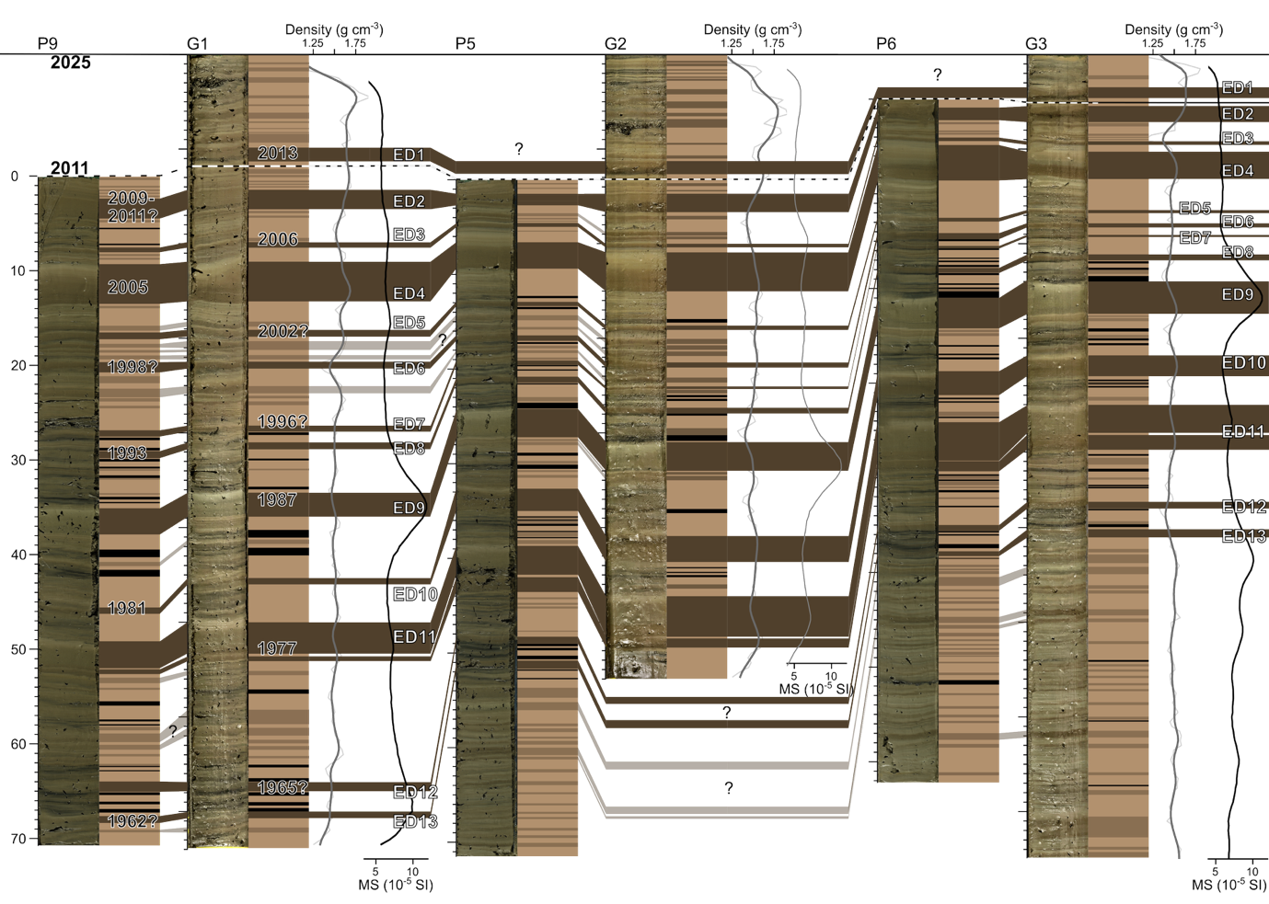Figure S1: Sediment-core correlation. For each of the three coring sites, a pair of sediment cores is shown: the left core corresponds to cores recovered in 2011 (P-cores; Hilbe & Anselmetti, 2014), and the right core to cores recovered in 2025 (G-cores; this study). Density (g cm⁻³) and magnetic susceptibility (10⁻⁵ (SI)) profiles are shown for each core. Core positions are indicated in Figure 1c. Event deposits (EDs) that could be confidently traced throughout the cores are indicated in dark brown, whereas local EDs are shown in light brown. Organic-matter-rich layers are shown in black. The average ages of EDs were estimated using sedimentation rates calculated for the 2011–2025 interval using coring sites P9/G1 and P5/G2 (see Supplementary Table S1).
Table S1: Events-deposits thicknesses and mean ages
ED# | G1 (2025) |  |  | P9 (2011) |  |  | G2 (2025) |  |  | P5 (2011) |  |  | G3 (2025)* |  |  | P6 (2011)* |  |  | All cores
 | x₁-x₂ (cm) | t (cm) | Age (y) | x₁-x₂ (cm) | t (cm) | Age (y) | x₁-x₂ (cm) | t (cm) | Age (y) | x₁-x₂ (cm) | t (cm) | Age (y) | x₁-x₂ (cm) | t (cm) | Age (y) | x₁-x₂ (cm) | t (cm) | Age (y) | Mean t (cm) | Mean age (y) | Age inferred (y)
ED1 | 9.8-11.3 | 1.5 | 2014.1 | Not deposited  (post 2011) |  |  | 11.3-12.6 | 1.3 | 2012.4 | Not deposited  (post 2011) |  |  | 3.5-4.6 | 1.1 | 2016.3 | Not deposited  (post 2011) |  |  | 1.3 | 2013.3±1.2 | 2013
ED2 | 14.3-16.4 | 2.1 | 2011.4 | 2.4-4.5 | 2.1 | 2008.3 | 14.7-16-6 | 1.9 | 2010.8 | 1.5-2.7 | 1.2 | 2010.7 | 5.5-7.1 | 1.6 | 2015.3 | 0.9-1.1 | 0.2 | 2009.3 | 1.5 | 2010.3±0.4 | 2011
ED3 | 19.9-20.4 | 0.5 | 2006.8 | 7.5-8 | 0.5 | 2005 | 20-20.4 | 0.4 | 2005.3 | 4.6-5 | 0.4 | 2007.2 | 9.1-9.5 | 0.4 | 2009 | 4-4.4 | 0.4 | 2001.5 | 0.4 | 2006.1±0.3 | 2006
ED4 | 21.9-26.1 | 4.2 | 2005.2 | 9.3-13.5 | 4.2 | 2003.6 | 20.9-25 | 4.1 | 2005.8 | 6.6-9.4 | 2.8 | 2005.4 | 10.3-13.2 | 2.9 | 2007 | 4.8-8.5 | 3.7 | 2000.5 | 3.7 | 2005±0.3 | 2005
ED5 | 29.1-29.8 | 0.7 | 2001.8 | 16.5-17.2 | 0.7 | 2001 | 28.6-29.1 | 0.5 | 2001.8 | 12.9-13.3 | 0.4 | 2001.6 | 16.4-16.7 | 0.3 | 1999 | 12.5-12.9 | 0.4 | 1990.5 | 0.5 | 2001.6±0.1 | 2002?
ED6 | 32.4-33.2 | 0.8 | 1998.9 | 19.6-20.7 | 1.1 | 1998.8 | 32.5-33.1 | 0.6 | 1998 | 16.5-17 | 0.5 | 1998 | 17.8-18.2 | 0.4 | 1996.3 | 14.2-14.8 | 0.6 | 1987.4 | 0.7 | 1998.4±0.5 | 1998
ED7 | 39.2-39.8 | 0.6 | 1992.3 | 26.9-27.5 | 0.6 | 1991.3 | 35-35.3 | 0.3 | 1995.9 | 19.1-19.6 | 0.5 | 1995.7 | 18.9-19.2 | 0.3 | 1994.5 | 15.5-15.8 | 0.3 | 1985.6 | 0.4 | 1993.8±2 | 1996?
ED8 | 41-41.7 | 0.7 | 1990.9 | 29-29.8 | 0.8 | 1989.9 | 37.3-38 | 0.7 | 1993.7 | 20.8-21.5 | 0.7 | 1994.3 | 21.1-21.8 | 0.7 | 1989.8 | 17.8-18.3 | 0.5 | 1980.6 | 0.7 | 1992.2±1.8 | 1993
ED9 | 46.3-48-9 | 2.6 | 1985.8 | 35.1-37.8 | 2.7 | 1986.1 | 40.9-44 | 3.1 | 1990.4 | 24.2-27.2 | 3 | 1991.3 | 23.8-27.4 | 3.6 | 1984.8 | 21-24.2 | 3.2 | 1973.9 | 3 | 1988.4±3 | 1987
ED10 | 55.3-56 | 0.7 | 1978.7 | 45.6-46.2 | 0.6 | 1975.1 | 50.9-53.6 | 2.7 | 1982.8 | 32.6-35 | 2.4 | 1985.3 | 31.8-34 | 2.2 | 1973.8 | 28.7-31.2 | 2.5 | 1962.6 | 1.9 | 1980.5±3.3 | 1981
ED11 | 60-64.1 | 4.1 | 1974.2 | 49.2-52.6 | 3.4 | 1974.9 | 57.3-60.6 | 3.3 | 1978.7 | 38.7-42.5 | 3.8 | 1981.2 | 37-41.7 | 4.7 | 1966.3 | 34.1-39.3 | 5.2 | 1955.4 | 4.1 | 1977.8±3.5 | 1977
ED12 | 76.9-77.8 | 0.9 | 1960.1 | 64-65.1 | 1.1 | 1959.7 | Not reached |  |  | 48.3-49 | 0.7 | 1974.8 | 47.3-48 | 0.7 | 1952.3 | 45-45.6 | 0.6 | 1941.1 | 0.8 | 1964.9±0.3 | 1965?
ED13 | 80-80.8 | 0.7 | 1957.6 | 67.6-68.3 | 0.7 | 1956.4 | Not reached |  |  | 50.8-51.6 | 0.8 | 1972.8 | 50.2-51 | 0.8 | 1946.8 | 47.7-48.2 | 0.5 | 1935.9 | 0.8 | 1962.3±0.8 | 1962?

Event-deposit characteristics and estimated ages for cores G1, G2, and G3, based on background sedimentation rates of 0.63, 0.67, and 0.33 cm yr⁻¹, respectively, constrained by the 2011 and 2025 coring campaigns (corresponding bulk sedimentation rates: 0.85, 0.94, and 0.36 cm yr⁻¹). The top (x₁) and bottom (x₂) of each event deposit are measured from the top of the respective cores (see Fig. S1); t denotes deposit thickness (cm). Ages derived from coring site P6/G3 differ from those obtained at P9/G1 and P5/G2 and were therefore excluded from the mean age calculations.

S2: XRF results for sediment core G1
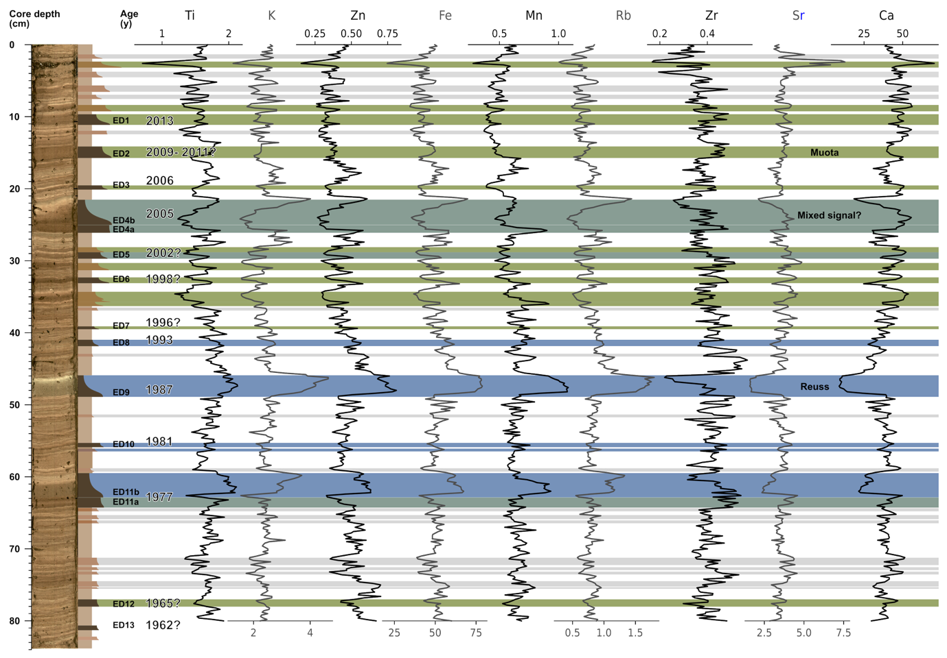
Figure S2: Sediment core G1 and associated XRF elemental profiles normalised to a closed sum. Shown elements include Ti, K, Zn, Fe, Mn, Rb, Zr, Sr, and Ca. Event deposits (EDs) enriched in terrigenous elements are attributed to a Reuss catchment origin and are indicated in blue. EDs relatively enriched in Sr and Ca are attributed to the predominantly carbonate Muota catchment and are shown in olive green, whereas EDs with a possibly mixed origin are shown in dark green. Thinner EDs with more ambiguous geochemical signatures are indicated in light grey.

S3: Downslope evolution of turbidity currents
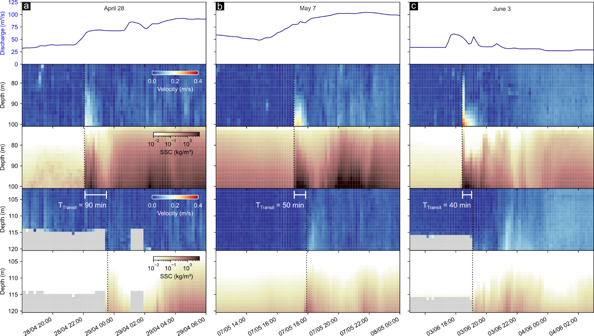

Figure S3: Turbidity currents recorded on April 28 (a), May 5 (b), and June 3 (c) by ADCP1 and ADCP2, showing water-column velocity (m s⁻¹) and suspended sediment concentration (SSC, kg m⁻³). Lower velocity and SSC values are observed at the more distal instrument (ADCP2) for all three events. Greyed-out areas in (a) and (c) indicate no data bins, which are attributable either to channel-wall reflections or, more likely, to insufficient sediment concentrations to generate adequate acoustic backscatter for reliable velocity measurements. This interpretation is supported by the fact that, when the turbidity current arrives, measurements extend down to the lakebed.
S4: Evidence for enhanced riverine sediment delivery on April 28-29.
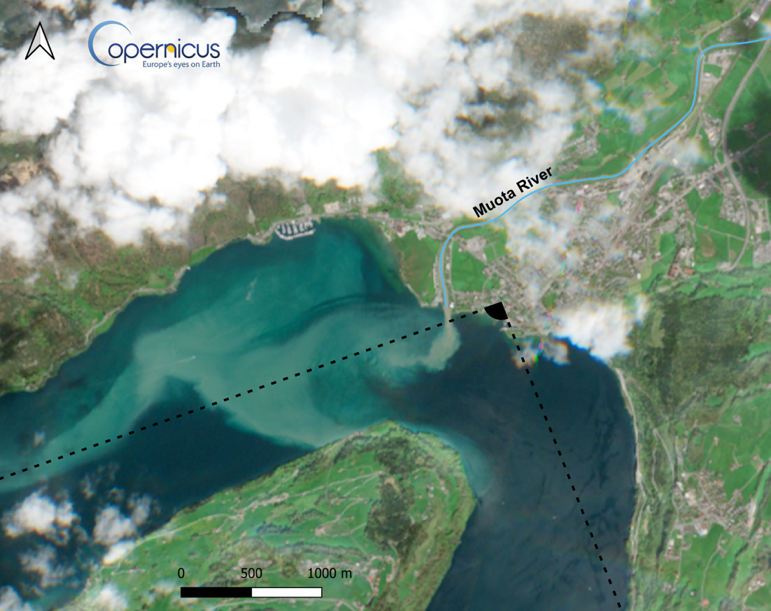
Figure S4: Satellite image acquired on April 29, 2024, the morning following the turbidity current that occurred during the night of April 28–29, showing a highly turbid river plume at the Muota inflow. Camera position and view angle of Video S1 is indicated. Sentinel-2 L2A (Copernicus Sentinel data), accessed via Copernicus Browser.

Video S1: Evidence for enhanced riverine sediment delivery on May 7
Webcam images from Brunnen acquired between 06:00 and 17:10 UTC are provided as Supplementary Video S1 (Video S1.gif, Graphical Interchange Format). The camera position and viewing direction are shown in Fig. S4. Original camera timestamps were recorded in local time (UTC+2) and converted to UTC for consistency with other measurements presented in this study.
Precipitation begins in the catchment at 06:00 UTC. A sediment-laden plume is visible by 07:10 UTC and persists throughout the day, intensifying during the afternoon. At 17:10 UTC, a turbidity current is recorded at ADCP1.

Video S2: Evidence for enhanced riverine sediment delivery on June 3
Webcam images from Brunnen acquired between 16:00 and 19:00 UTC are provided as Supplementary Video S2 (Video S2.gif, Graphical Interchange Format).
At 16:00 UTC, the river inflow appears clear. Between 16:40 and 18:00 UTC, a sediment-laden plume extends into the lake, preceding the turbidity current recorded at 18:30 UTC. After approximately 18:00 UTC, changes in lighting conditions limit surface observations; however, the final frames again show a clear river inflow.

No webcam imagery is available for 28 April, as the precipitation event and associated turbidity current occurred during night-time hours.
S5: Antecedent moisture in the catchment
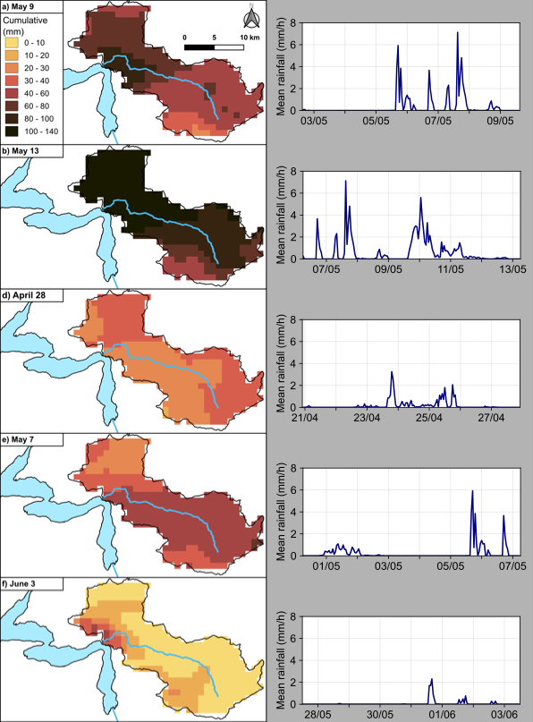
Figure S5: Seven-day cumulative precipitation over the Muota River catchment preceding the events shown in Fig. 4. Maps correspond to the seven days prior to (a) 9 May, 15 UTC; (b) 13 May, 06 UTC; (c) 27 April, 22 UTC; (d) 7 May, 06 UTC; and (e) 3 June, 12 UTC. Line plots displayed alongside the maps show the temporal distribution of mean catchment precipitation (mm h⁻¹) over the same seven-day period.

