Supplemental Information

Site Locations.

Iona-1 research core (29º13.51’N, 100º44.49’W)
The upper part of the Eagle Ford Group (Gr.) and lowermost Austin Chalk crop out along Sycamore Creek about 18 km (11 miles) southeast of Del Rio near the Val Verde-Kinney County line, Texas (TX), USA. In January 2012, Shell International Exploration and Production Inc. drilled the research core Iona-1, approximately 600 m behind the Sycamore Creek bluff. From the surface, the core recovered the lower 40 m of the Austin Chalk, a 110 m long interval representing a nearly complete record of the Eagle Ford Gr. (or Boquillas Formation, Fm.) and an upper part of the underlying Buda Limestone. A total of 180 meters of core were recovered spanning the lower Cenomanian to lower Coniacian (Eldrett et al., 2015). The underlying Buda Limestone and overlying Austin Chalk comprise extremely bioturbated limestones with thin marl beds and rare bentonites, whereas the Eagle Ford Gr. is characterized by organic-rich marl beds, thinner limestone beds and numerous (~270) thin-bedded, bentonite beds (Eldrett et al. 2015; Minisini et al., 2018). The Iona-1 and Innes-1 research cores have been to focus of over a decade of interdisciplinary analyses documented in over 23 publications and the reader is referred to an extended abstract for a summary of these studies (cf. Minisini et al., 2020).

Innes-1 research core (29º49.51’N, 101º37.34’W)
Cenomanian to Turonian strata are also exposed in road cuts along US Highway 90, northwest of Del Rio near the town of Langtry in Terrell County, TX (Pessagno, 1969; Donovan and Staerker, 2010; Donovan et al., 2012; Lowery et al., 2014), approximately 160 km (100 miles) WNW of the Iona-1 core, and 50 km (35 miles) east of the Lozier Canyon outcrop. Shell International Exploration and Production Inc. drilled the research core Innes-1, immediately behind one of these exposures recovering the lower 20 m of the Austin Chalk, over 60 m of the Eagle Ford Gr. (Boquillas Fm.) and underlying Buda and Salmon Peak Limestone Formations.

USGS Portland-1 (38º 22.36’N, 105º 01.18’ W)
Sedimentary rocks were also analysed for comparison from the USGS Portland-1 core (38º 22.36’N, 105º 01.18’ W) located in the central Cretaceous Western Interior Seaway (KWIS), near the base Turonian GSSP section (Kennedy et al., 2000, 2005) at Pueblo (Colorado, USA). The new data cover the Cenomanian equivalent interval spanning from oldest to youngest: the Dakota Sandstone, Graneros Shale, Lincoln Limestone, Harland Shale and lowermost part of the Bridge Creek Limestone. The new δ¹³C_{organic} isotope data collected was integrated with existing δ¹³C_{organic} data from this core (Sageman et al., 2006; Duvivier et al., 2014; Joo and Sageman, 2014).

Waco Composite Section
The outcrops near Waco, TX were studied by Boling (2013) as part of an unpublished dissertation thesis. A composite section was constructed from nine outcrops located around McLennan County, TX. The locations and detailed descriptions are provided in appendix A of Boling (2013). Above the Buda Limestone, the Pepper and Eagle Ford Fms are exposed to outcrop. The Eagle Ford Fm consists of Lake Waco, South Bosque, and Arcadia Park Members (after Adkins and Lozo, 1951). The Pepper Formation is a black, non-calcareous, claystone with thin sandy intervals. Despite the black colouration in outcrops, redox sensitive trace metals are not enriched, indicating an oxic depositional environment (Boling, 2013). The contact between the Pepper Shale and the overlying Eagle Ford Fm. is disconformable (illustrated in the nearby Waco core by Brown and Pierce, 1962). The Lake Waco member consists of dark, silty shale with interspersed laterally discontinuous carbonate layers (or small lenses composed of coarse shell fragments) and numerous bentonite beds. Redox-sensitive trace metals are enriched, indicating an anoxic depositional environment (Boling, 2013). The upper Eagle Ford (South Bosque member) is characterized by abundant calcite in its lower portion which steadily declines up section. At the top of the South Bosque the mudrock becomes calcite-free and termed Arcadia Park Formation (Adkins and Lozo, 1951). A total of 166 samples were collected from these outcrops and analyzed for total organic carbon (TOC), total organic nitrogen (TON), δ¹³C_{organic}, δ¹⁵N_{organic} and inorganic geochemistry using the following methods. Samples were pretreated with 10% HCl in silver cups before combustion in a Costech elemental analyzer. The evolved C and N gases were then conveyed to a Thermo Scientific™ Delta V Advantage stable isotope mass spectrometer for C and N isotope ratio determination. The analytical precision for concentration analysis is +/- 0.08 for carbon and ± 0.01for N. Precision for isotopic analysis is ± 0.03 for δ¹³C and ± 0.06 for δ¹⁵N. Full results can be found in Boling (2013).

BB2 [stretches from 29.256116°N, 103.011813°W to 29.2544°N, 103.016807°W)
Section BB2 is located in Big Bend National Park, TX (accessible from the Ernst Tinaja Trailhead at the east end of Old Ore Road), contains a west-dipping Eagle Ford Gr. section approximately 53 m thick, and is exposed along a ~1 km stretch of the 25 m wide Ernst Tinaja Canyon. The outcrop exposes the entire Eagle Ford Gr. (locally named Boquillas Fm), from the sharp contact with Buda Fm. in the east to the gradational contact with Austin Chalk in the west. The section is much more indurated than other Eagle Ford Gr. sections in this study and has experienced some deformation. The section was measured and sampled in 2011-2012 by the authors utilizing permits from the National Park Service. Additional details include a correlation panel with other Eagle Ford Gr. sections in SW Texas, cm-scale measured section, lithologic log, sedimentary facies and structures, gamma ray logs, and a variety of laboratory analytical data can be found in Minisini et al. (2018), particularly Figures S13, and S21.

References.
Adkins, W.S. and Lozo, F.E., 1951. Stratigraphy of the Woodbine and Eagle Ford, Waco area, Texas. Fondren Science Series, 4, 1-77.
Boling, K.S., 2013. Controls on the accumulation of organic matter in the Eagle Ford Group, Central Texas, USA (Doctoral dissertation, MS thesis, Baylor University, Waco, Texas).
Brown, C.W. and Pierce, R.L., 1962. Palynologic correlations in Cretaceous Eagle Ford Group, northeast Texas. AAPG Bulletin, 46(12), pp.2133-2147.
Donovan, A.D. and Staerker, T.S., 2010. Sequence stratigraphy of the Eagle Ford (Boquillas) Formation in the subsurface of South Texas and outcrops of West Texas.
Donovan, A.D., Staerker, T.S., Pramudito, A., Li, W., Corbett, M.J., Lowery, C.M., Romero, A.M. and Gardner, R.D., 2012. The Eagle Ford outcrops of West Texas: a laboratory for understanding heterogeneities within unconventional mudstone reservoirs.
Du Vivier, A.D., Selby, D., Sageman, B.B., Jarvis, I., Gröcke, D.R. and Voigt, S., 2014. Marine 187Os/188Os isotope stratigraphy reveals the interaction of volcanism and ocean circulation during Oceanic Anoxic Event 2. Earth and Planetary Science Letters, 389, pp.23-33.
Eldrett, J.S., Ma, C., Bergman, S.C., Lutz, B., Gregory, F.J., Dodsworth, P., Phipps, M., Hardas, P., Minisini, D., Ozkan, A. and Ramezani, J., 2015. An astronomically calibrated stratigraphy of the Cenomanian, Turonian and earliest Coniacian from the Cretaceous Western Interior Seaway, USA: Implications for global chronostratigraphy. Cretaceous Research, 56, pp.316-344.
Joo, Y.J. and Sageman, B.B., 2014. Cenomanian to Campanian carbon isotope chemostratigraphy from the Western Interior Basin, USA. Journal of Sedimentary Research, 84(7), pp.529-542.
Kennedy, W.J., Walaszczyk, I. and Cobban, W.A., 2000. Pueblo, Colorado, USA, candidate Global Boundary Stratotype Section and Point for the base of the Turonian Stage of the Cretaceous, and for the base of the Middle Turonian Substage, with a revision of the Inoceramidae (Bivalvia). Acta Geologica Polonica, 50(3), pp.295-334.
Kennedy, W.J., Walaszczyk, I. and Cobban, W.A., 2005. The global boundary stratotype section and point for the base of the Turonian stage of the Cretaceous: Pueblo, Colorado, USA. Episodes Journal of International Geoscience, 28(2), pp.93-104.
Lowery, C.M., Corbett, M.J., Leckie, R.M., Watkins, D., Romero, A.M. and Pramudito, A., 2014. Foraminiferal and nannofossil paleoecology and paleoceanography of the Cenomanian–Turonian Eagle Ford Shale of southern Texas. Palaeogeography, Palaeoclimatology, Palaeoecology, 413, pp.49-65.
Minisini, D., Eldrett, J., Bergman, S.C. and Forkner, R., 2018. Chronostratigraphic framework and depositional environments in the organic‐rich, mudstone‐dominated Eagle Ford Group, Texas, USA. Sedimentology, 65(5), pp.1520-1557.
Minisini, D., Bergman, S.C., Eldrett, J.S. 2025. The value of integrated high-resolution studies: The Eagle Ford example. Perkins-Rosen GCSSEPM Conference abstract. doi: https://doi.org/10.5724/gcs.38.177
Pessagno, E.A., 1969. Upper Cretaceous stratigraphy of the western Gulf Coast area of Mexico, Texas, and Arkansas. Geological Society of America Memoir 111, pp. 130. doi: 10.1130/MEM111-p1
Sageman, B.B., Meyers, S.R. and Arthur, M.A., 2006. Orbital time scale and new C-isotope record for Cenomanian-Turonian boundary stratotype. Geology, 34(2), pp.125-128.
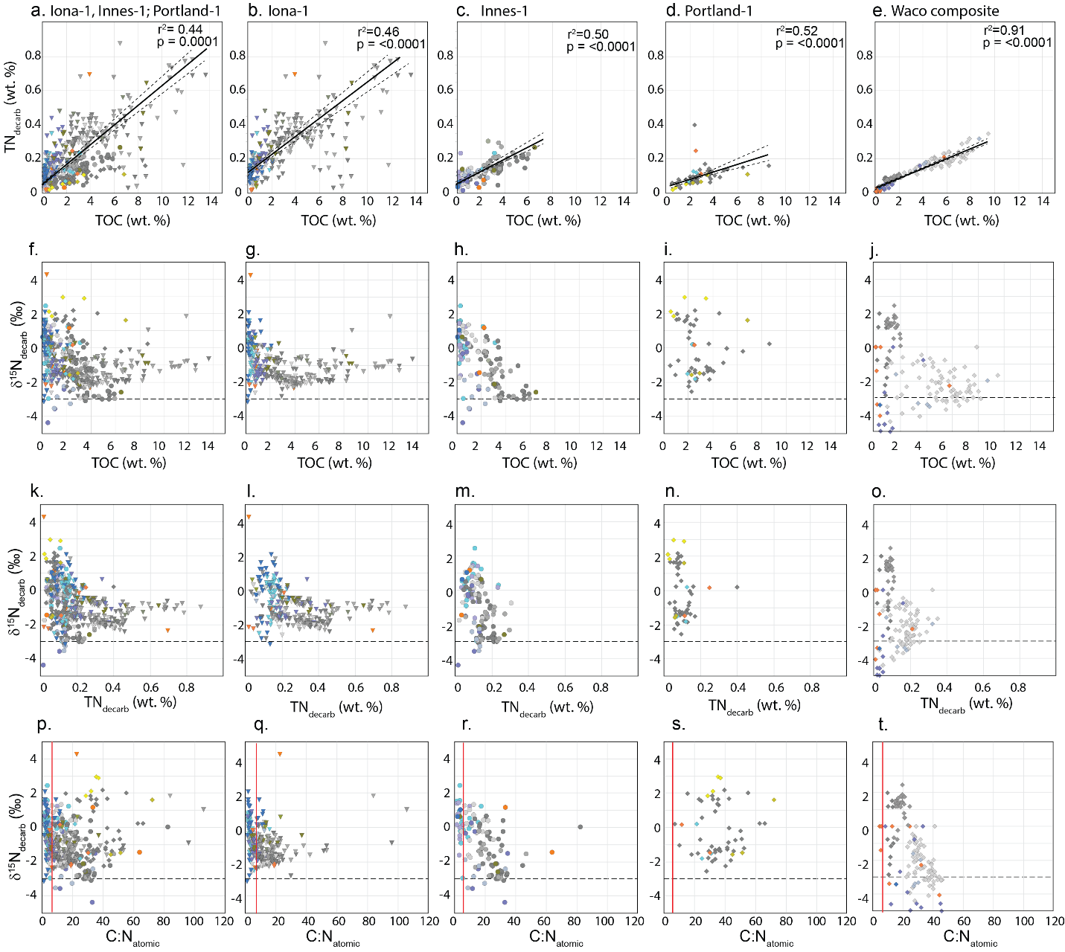
Fig. S1. Bivariate plots. a-e. TN_{decarb} versus TOC; f-j. δ¹⁵N_{decarb} versus TOC; k-o. δ¹⁵N_{decarb} versus TN_{decarb}; p-t. δ¹⁵N_{decarb} versus C:N_{atomic}. The lower limit of δ¹⁵N values observed in other global records (after Ruvalcaba Baroni et al., 2015; Danzelle et al., 2020) is indicated with the dashed horizontal line. The red vertical line in p-t. represents the C:N redfield ratio (6.625) of marine organic matter in modern sediments. Sample colours represent sedimentary facies types (see Fig. S2 for legend). Plots are in columns according to the cores displayed and as follows: far left: Iona-1, Innes-1 and Portland-1 plotted; followed by each core separately: Iona-1; Innes-1, Portland-1; with Waco outcrop composite section plotted on the far-right column.

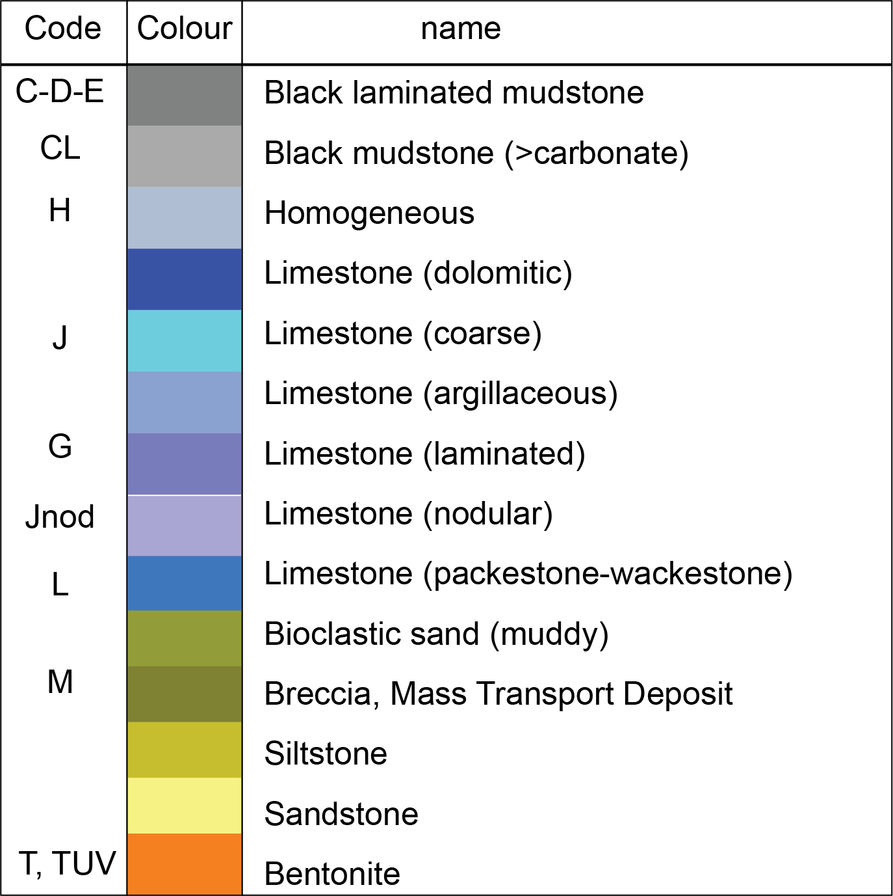
Fig. S2. Facies scheme used in bivariate plots. Code simplified after Minisini et al. (2018). Those without code refer to facies encountered from Portland-1 core (USGS CRC E099) and Waco outcrops (Boling, 2013).

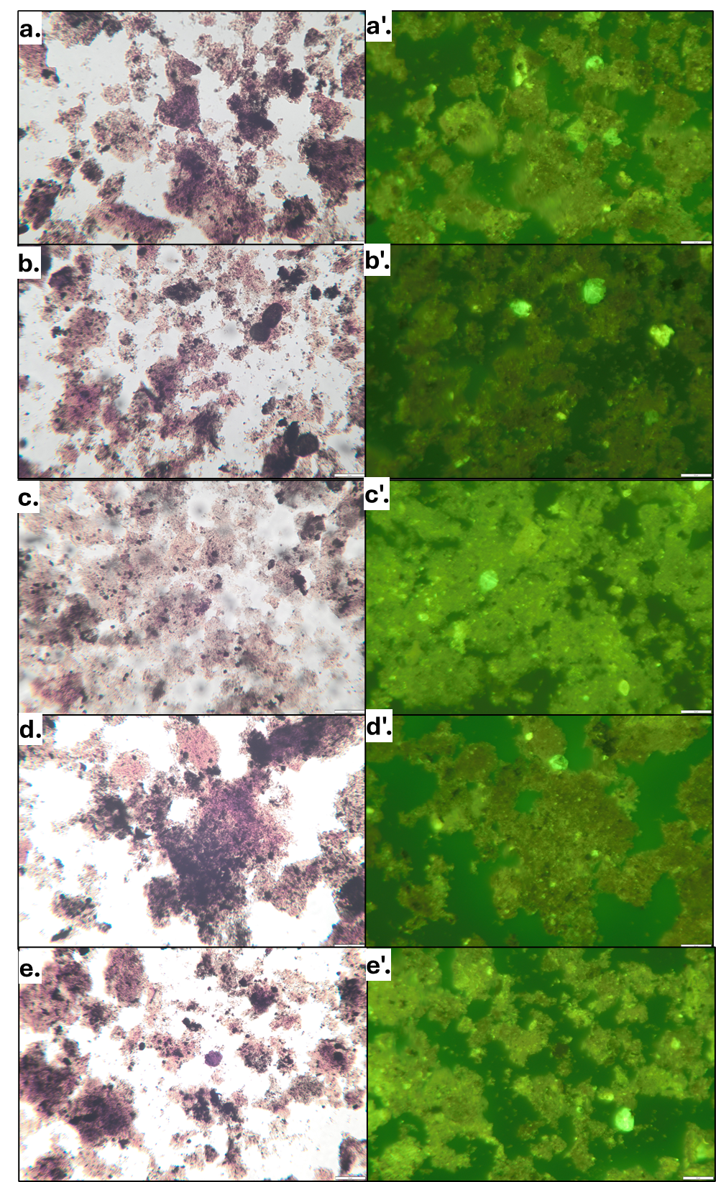
Fig. S3. White light and ultra-violet light photomicrographs of kerogen from Iona-1 core illustrating the granular nature with variable fluorescence. a-a': Depth: 126.33m England Finder coordinate: S43-4; b-b': Depth: 126.33m England Finder coordinate: P33-2; c-c': Depth: 64.50m, England Finder coordinate: V33-1; d-d': Depth: 122.18m, England Finder coordinate: O23-1; e-e': Depth: 130.74m, England Finder coordinate: Q25-4.

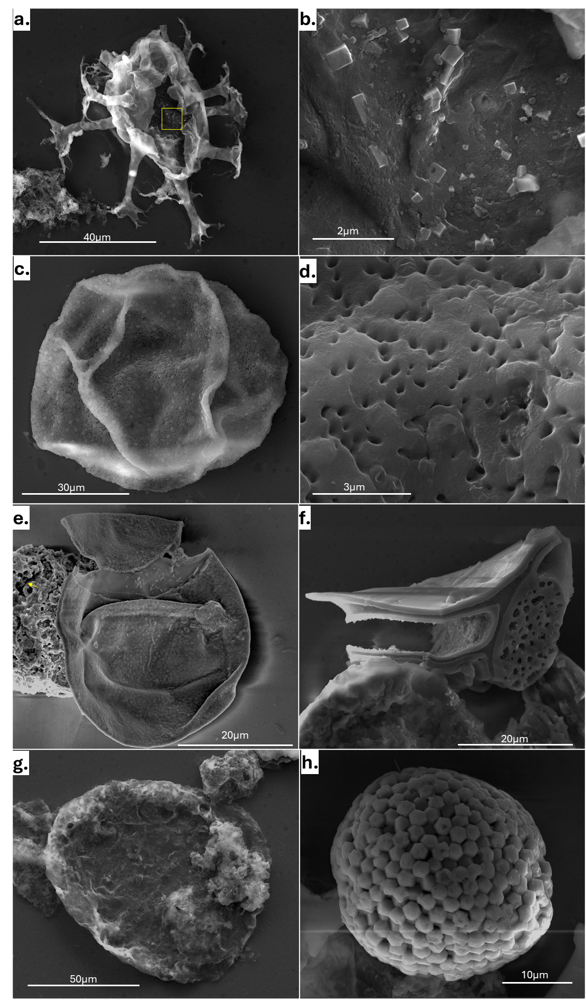
Fig. S4. Scanning Electron Microscopy (SEM) images of selected macerals from the Iona-1 core. The focus on the imagery was on palynomorphs and not the amorphous organic matter (AOM). a. Depth 69.86m, Oligosphaeridium spp., with abundant pyrite within the cyst archeopyle and processes, yellow box is the area of focus in image b; b. higher resolution image of the pyrite cubes within the dinocyst; c. Depth 114.04m: Tasmanites spp; d. higher resolution image of the wall structure; e. Depth 130.74m, Peridinioid dinoflagellate cyst with pyrite forming on cyst wall, left side captures AOM that is characterized by alveolar network and extracellular polymeric substances (EPS, yellow arrow) indicative of bacteria (Pacton et al. 2011); f. Depth 130.74m, structured phytoclast that is relatively rare in the lower Eagle Ford; g. Depth 130.74m, Leiosphaeridia spp., that appears to be covered in EPS; h. Depth 148.23m, pyrite sphere

