Supplementary Data
Evolution of a Tethyan carbonate platform through the Jurassic tectonic and climatic upheavals

Quentin Deloume^{*1,2,3}, Simon Andrieu^{2,4,5}, Éric Lasseur², Thierry Pélissié⁷, Églantine Husson², Benjamin Brigaud^{1,6}

¹Université Paris-Saclay, CNRS, GEOPS, 91405 Orsay, France
²BRGM, 3 avenue Claude Guillemin, BP 36009, 45060 Orléans, France
³Beicip-Franlab, 232 avenue Napoléon Bonaparte, 92500 Rueil-Malmaison, France
⁴Department of Geoscience, Aarhus University, Høegh-Guldbergs Gade 2, 8000 Aarhus C, Denmark
⁵Laboratoire de Géologie de Lyon : Terre, Planètes et Environnement, CNRS, Ecole Normale supérieure de Lyon, Université de Lyon 1
⁶Institut universitaire de France (IUF), Paris, France
⁷Parc naturel régional des Causses du Quercy, Géoparc mondial UNESCO, BP 10, 11 rue Traversière, 46240, Labastide-Murat, France
Author Note
Quentin Deloume: https://orcid.org/0000-0002-7582-742X
Simon Andrieu: https://orcid.org/0000-0003-1975-1296
Éric Lasseur: https://orcid.org/0000-0002-9857-2052
Thierry Pélissié: https://orcid.org/0000-0003-2975-2903
Églantine Husson: https://orcid.org/0000-0002-4434-3035
Benjamin Brigaud: https://orcid.org/0000-0001-6961-2177

*Corresponding author: Quentin Deloume (quentin.deloume@beicip.com)
1. Sedimentary facies analysis
Twenty-five facies were identified in the Aalenian to Oxfordian deposits of the northern Aquitaine Basin, based on textures, skeletal and non-skeletal allochems, and biogenic and sedimentary structures (Table 1). These facies are grouped into 7 facies associations (FA1-FA7), each corresponding to a distinct depositional environment along a downdip profile ranging from lower offshore to paleosoil and palustrine settings.
  - Lower offshore environment (facies association FA1)
The lower offshore deposits (facies association FA) are exclusively located under the Cenozoic and Cretaceous cover of the northern Aquitaine Basin. Their description is based on facies data from the deep boreholes of the Aquitaine Basin.
Description – This facies association contains two facies: marls (F1a) and marl/clayey carbonate mudstone alternations (F1b). The facies F1a is characterized by m-thick dark marl deposits containing pyritized ammonites and brachiopods, while facies F1b corresponds to intensely bioturbated clayey limestones and marl/clayey carbonate mudstone alternations.
Interpretations – The very fine grain size, mud-supported texture, absence of hydrodynamic sedimentary features, abundant bioturbations and the presence of ammonites and belemnites indicate open marine conditions in a low energy environment under the storm wave base (SWB). The presence of pyrite indicates low oxygen levels and reducing seafloor conditions (Harder, 1980).
  - Upper offshore environment (facies association FA2)
The upper offshore deposits (facies association FA2) are only located in the Early Aalenian deposits (opalinum zone) in the Quercy area.
Description – This association includes two facies: marl/bioclastic wackestone to packstone alternations (F2a; Figure S1A) and clayey bioclastic wackestone to packstone (F2b; Figure S1B). The facies F2a consists of limestones rich in bioclastic debris alternating with marl interbeds above an erosive basal surface (Lézin, 2000). The facies F2b is characterized by fine-grained clayey bioclastic limestone beds and tempestite storm deposits with echinoderm debris and extraclasts (Lézin, 2000; Lézin et al., 2007).
Interpretations – In the facies F2a and F2b, the prevalence of echinoderms, cephalopods and common bioturbation indicates well-oxygenated and normal salinity conditions. Due to the occurrence of marl-limestone alternations (F2a), the muddy textures (wackestone to packstone) and the presence of tempestite storm deposits (F2b), we interpret these facies as having formed in upper offshore environments, between the storm wave base (SWB) and fair-weather wave base (FWWB).
  - Shoreface environment (facies association FA3)
Description – The shoreface environment (facies association FA3) encompasses five facies which are rich in bioclasts and grain-supported. Facies F3a is an echinoderm-bivalve packstone to grainstone (Figure S1C) comprised of bioclastic debris, perforations and tempestite deposits (Lézin, 2000; Lézin et al., 2007). The facies F3b consists of bioclastic-ooid packstone to grainstone (Figure S1D-G). This facies presents frequent benthic foraminifera (Coscinoconus limognensis, Redmondoides lugeoni, Chablaisia chablaisensis) and dispersed millimetric to centimetric coral fragments that are not forming coral bioconstruction (Pélissié, 1982). Lithocodium aggregatum and microbial agglutinated microfabrics are abundant in facies F3b Oxfordian deposits (Figure S1E-G). Facies F3c and F3d correspond respectively to ooid grainstone (Figure S2A), and peloidal/superficial ooid grainstone (Figure S2B). These facies can sometimes present bidirectional and tangential metric beddings, i.e., cross-bedding in dunes and small subordinate ripples (Figure S2C-E). Facies F3e is an oncoid-ooid grainstone to rudstone, characterized by pluricentimetric oncoids encrusted with foraminifera (Nubecularia) (Figure S2F) and skeletal allochems, mainly composed of bivalves and echinoderms.
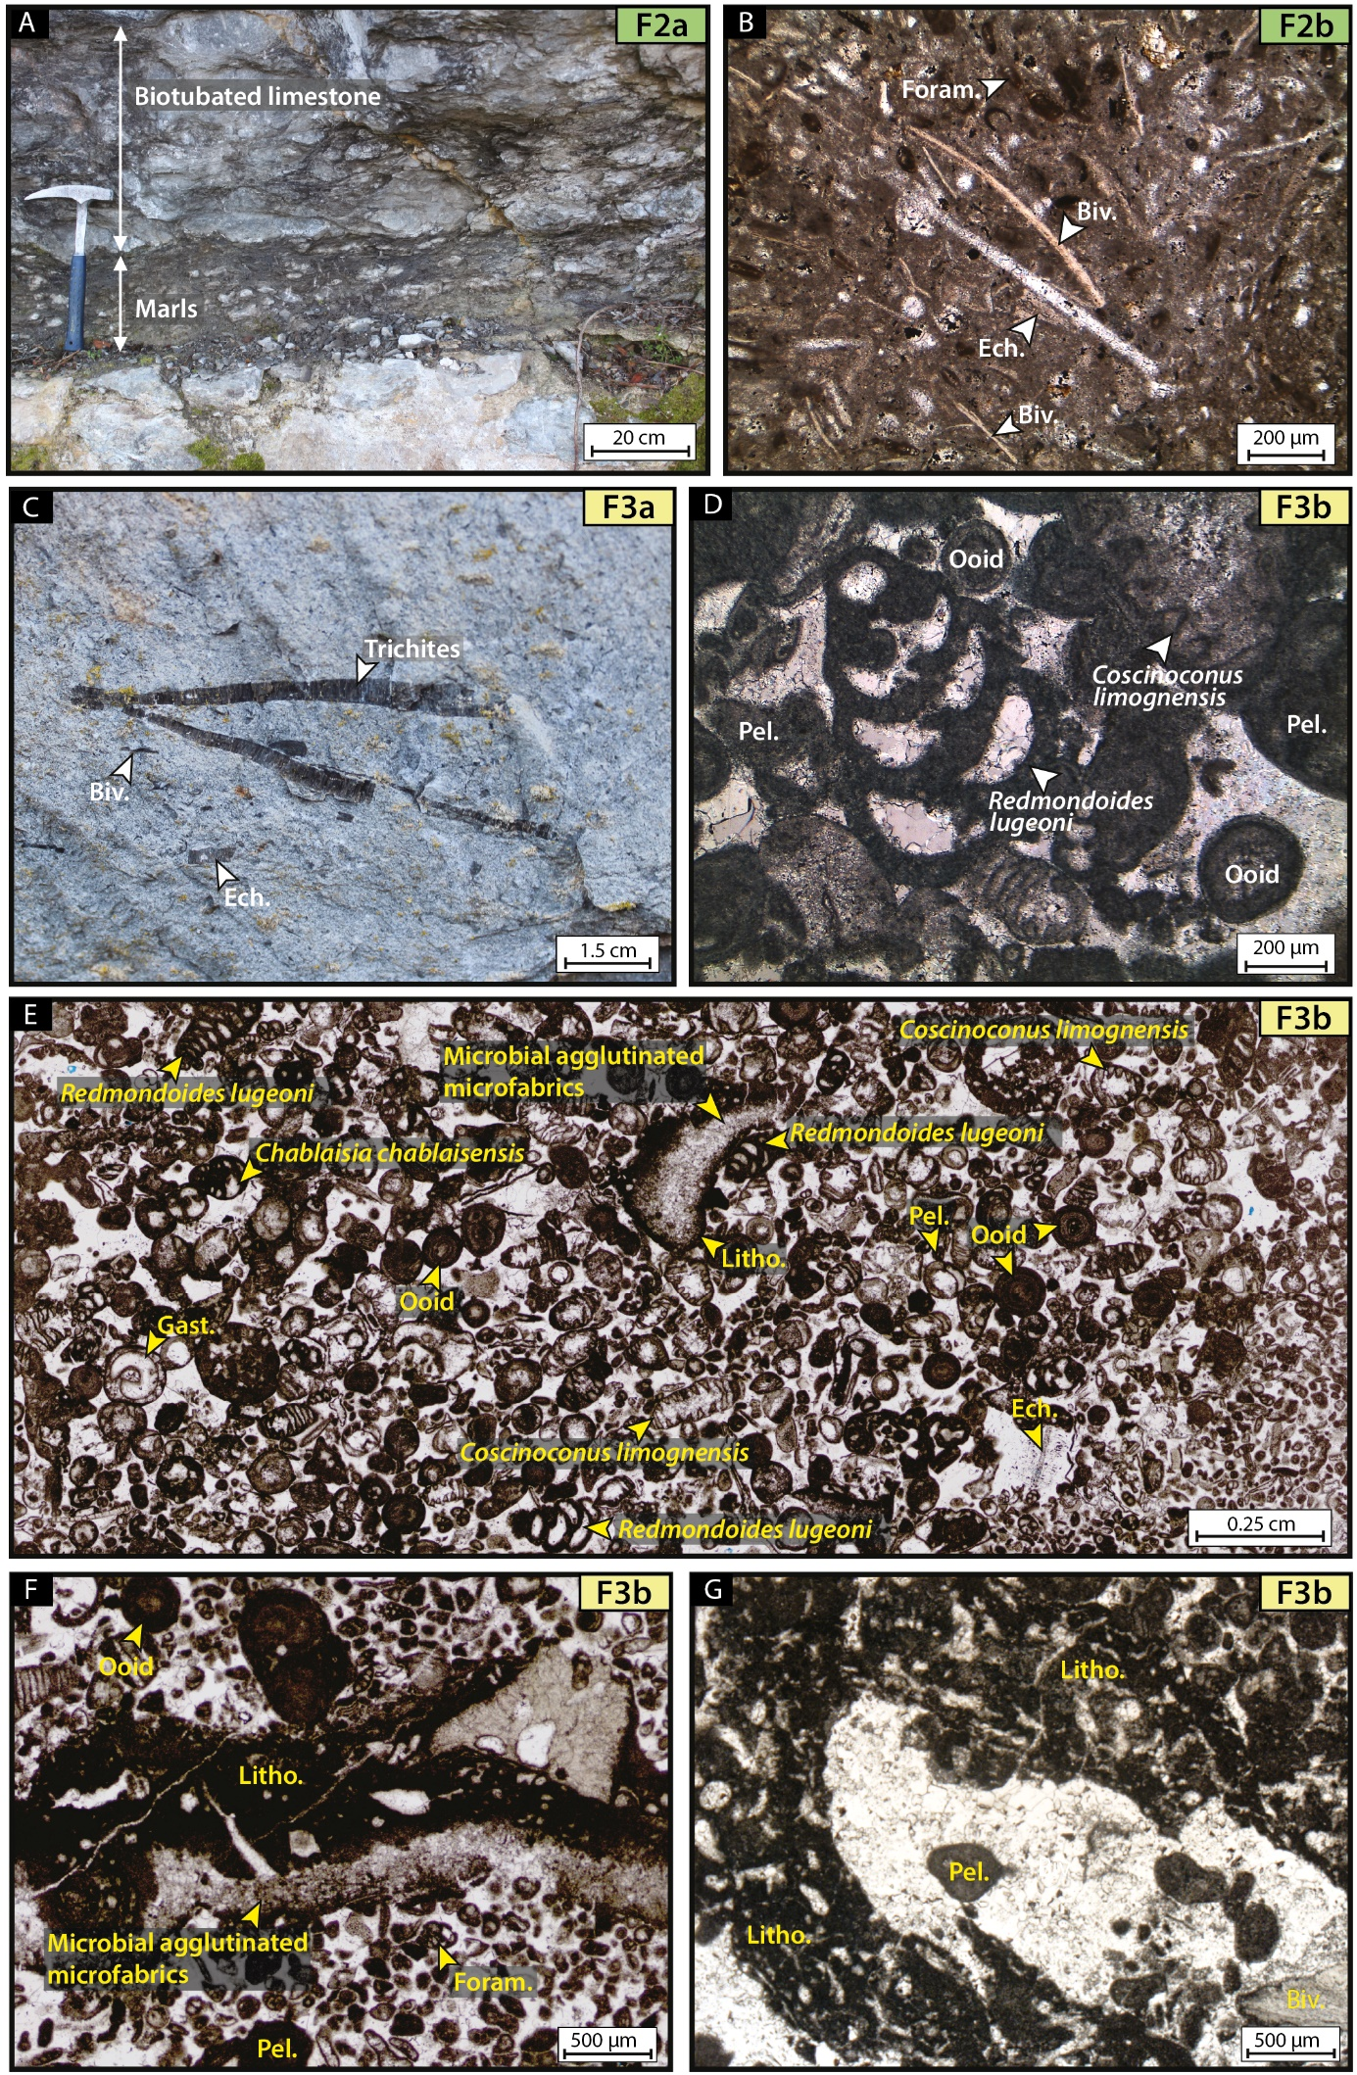
Figure S1: Field photographs and thin sections of upper offshore and shoreface environments (facies association FA2 and FA3). (A) Marls and bioturbated limestone alternations; facies F2a; Bruniquel outcrop (#1); Autoire Formation. (B) Clayey bioclastic wackestone to packstone containing bivalves (Biv.), echinoderms (Ech.) and foraminifera (Foram.); facies F2b; sample AUT1; Autoire outcrop (#32); Autoire Formation. (C) Echinoderm-bivalve packstone with bivalves (including Trichites) and echinoderms; facies F3a; Bruniquel outcrop (#1); Autoire Formation. (D) and (E) Bioclastic-ooid grainstones showing echinoderms, foraminifera (including Coscinoconus limognensis, Redmondoides lugeoni and Chablaisia chablaisensis), gastropods (Gast.), and non-skeletal allochems such as ooids, peloids (Pel.), microbial agglutinated microfabrics and Lithocodium encrustation (Litho.); facies F3b; samples COM2 and SLC8; Combe-Longue quarry (#6) and Saint-Cirq-Lapopie outcrop (#7); Saint-Géry Formation. (F) and (G) Bioclastic-ooid grainstones with foraminifera (Foram.), bivalves (Biv.), ooids, peloids (Pel.), microbial agglutinated microfabrics and Lithocodium encrustation; facies F3b, samples SCL8 and COM1; Combe-Longue quarry (#6) and Saint-Cirq-Lapopie outcrop (#7); Saint-Géry Formation.

Interpretations – In all facies, the occurrence of open-marine faunas such as bryozoans, echinoderms and corals indicate well-oxygenated marine water with normal salinity levels. In facies F3a, packstone to grainstone textures, fragmented bioclasts and preservation of tempestite storm deposits indicate the influence of storms in a lower shoreface environment, slightly above the fair-weather wave base (FWWB). In facies F3b to F3e, the grainstone texture and cross-bedding in dunes attest to highly hydrodynamic conditions of the shoreface environment. In facies F3b, the frequent occurrence of Lithocodium encrustations suggest oligotrophic conditions (Olivier et al. 2004). .
  - Deep subtidal lagoon (facies association FA4)
Description – The deep subtidal lagoon association (facies association FA4) contains two facies. The facies F4a is dominated by marls and mudstone-wackestone alternations (Figure S3A) containing numerous ostracods (Figure S3B), bivalves and brachiopods. The facies F4b corresponds to ferruginous bioclastic wackestone to packstone (Figures S3A and S3C-D). These two facies consist of tabular to irregular mudstone to packstone beds alternating with thin claystone and marl interbeds containing tempestite deposits in tabular limestone beds (Figure S3E-F). Bioturbations and perforations are common and the main skeletal allochems are bivalves, gastropods, brachiopods, echinoderms and benthic foraminifera.
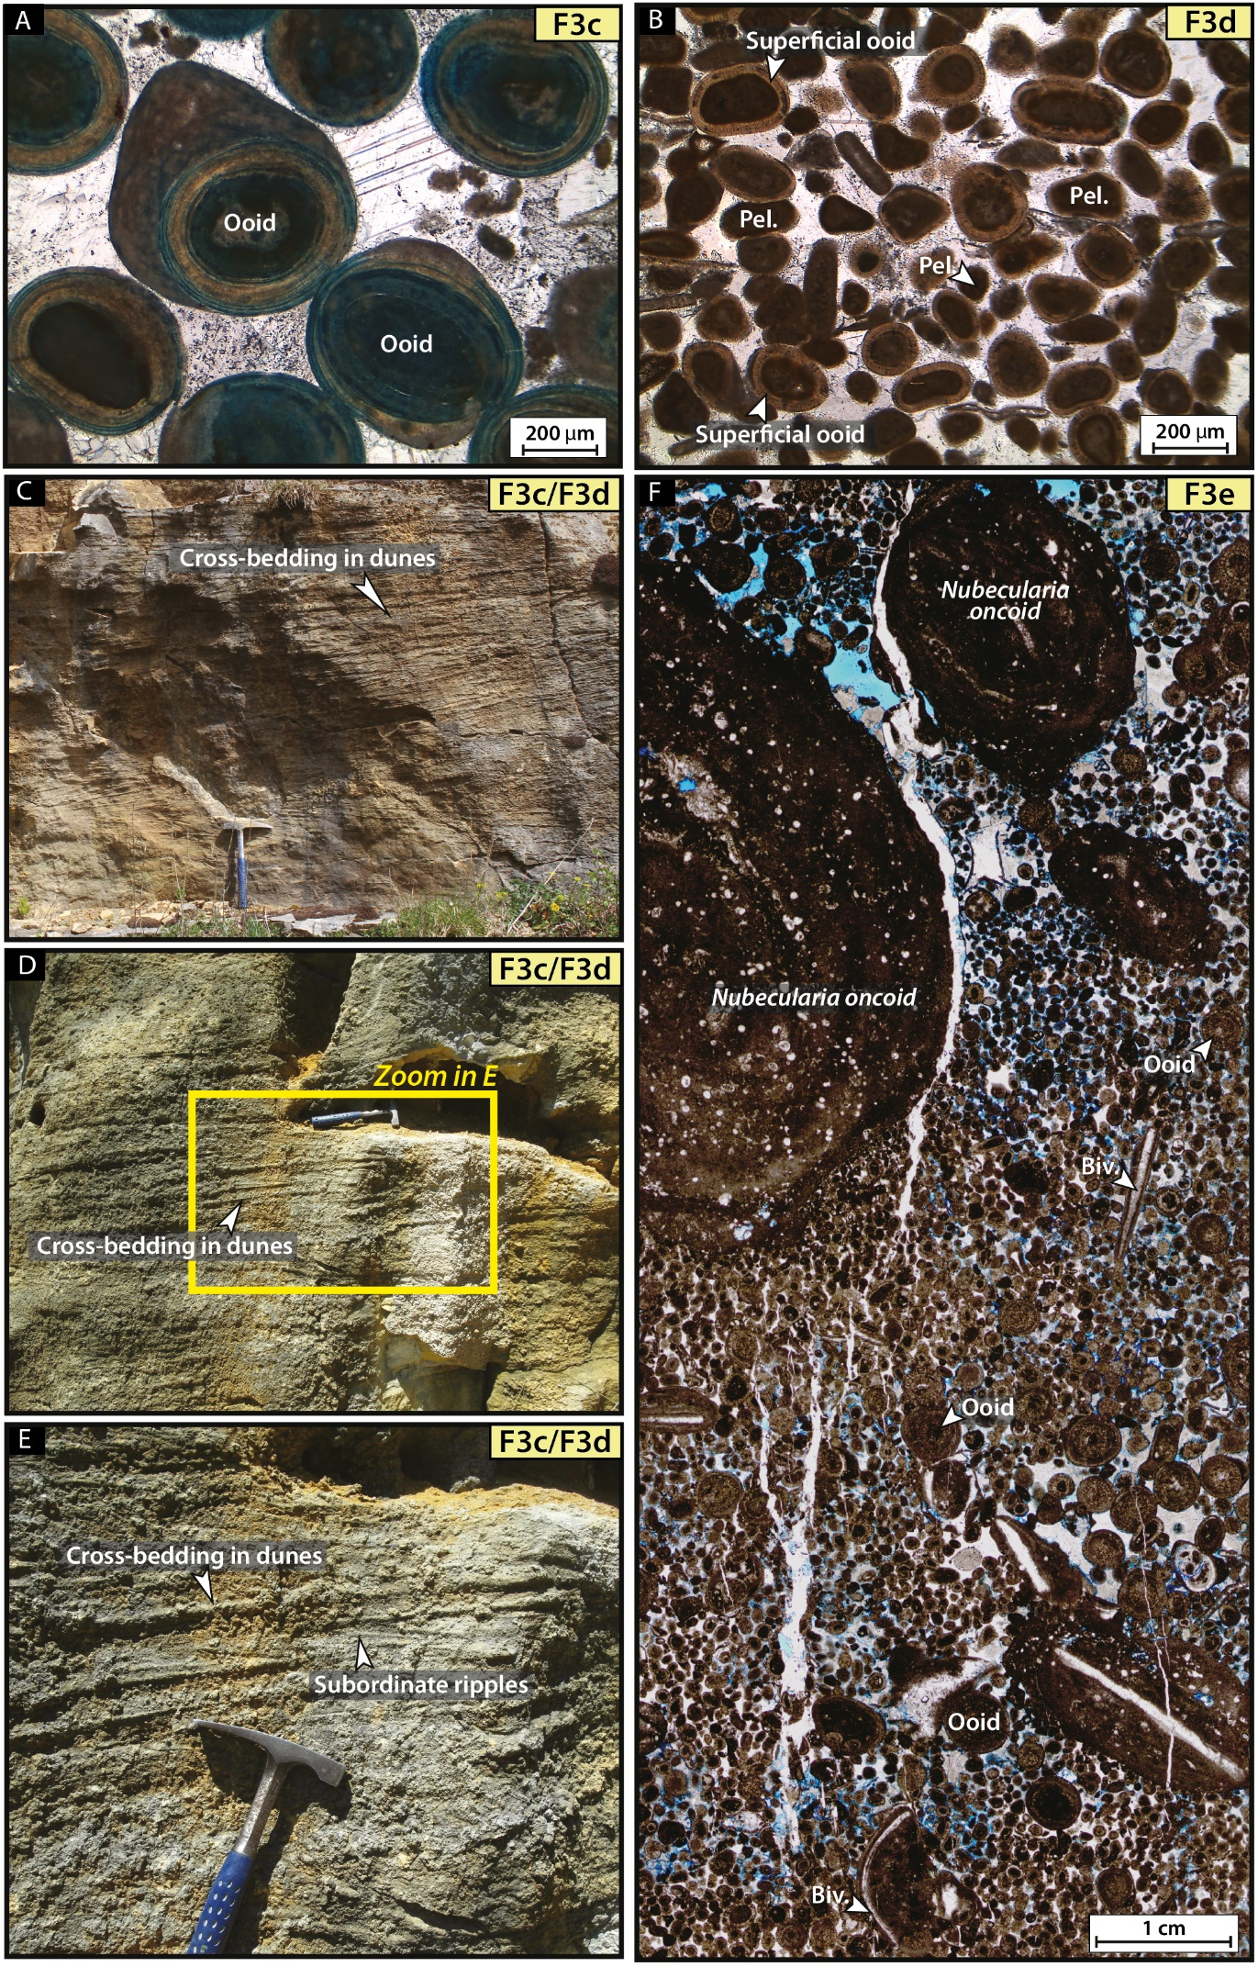
Figure S2: Field photographs and thin sections of shoreface environment (facies association FA3). (A) Ooid grainstone; facies F3c; sample MSC6; Marcilhac-sur-Célé outcrop (#22); Cajarc Formation. (B) Peloidal and superficial ooid grainstone; facies F3d; sample AFC1; Saint-Antonin-Noble-Val outcrop (#Y); Cajarc Formation. (C), (D) and (E) Former quarry displaying bidirectional cross-bedding in dunes and subordinate ripples; facies F3c and F3d; Rozier-Meynichou quarry (#47); Calcaire oolithique de Lastours Formation. (F) Oncoid-ooid grainstone to rudstone with Nubecularia oncoids, ooids, peloids and bivalves; facies F3e; sample AML16; Amiel outcrop (#5); Autoire Formation.

Interpretations – The presence of well-preserved fauna such as benthic foraminifera, bivalves and gastropods suggest normal-marine salinity. Additionally, the mud-supported texture indicates calm and low-energy environmental conditions. The local presence of tempestites (Figure S3E-F) indicates occasional episodes of strong water agitation. The absence of ammonites or belemnites in the marl and limestone alternations suggests an environment partially isolated from the offshore setting. This is consistent with the paleogeographic context during the Middle Jurassic, implying that these facies might be at least partially protected by an oolitic barrier westward. Therefore, we suggest that these facies formed in a deep subtidal lagoon environment partially protected by bioclastic to oolitic shoals but still exposed to periodic storms.
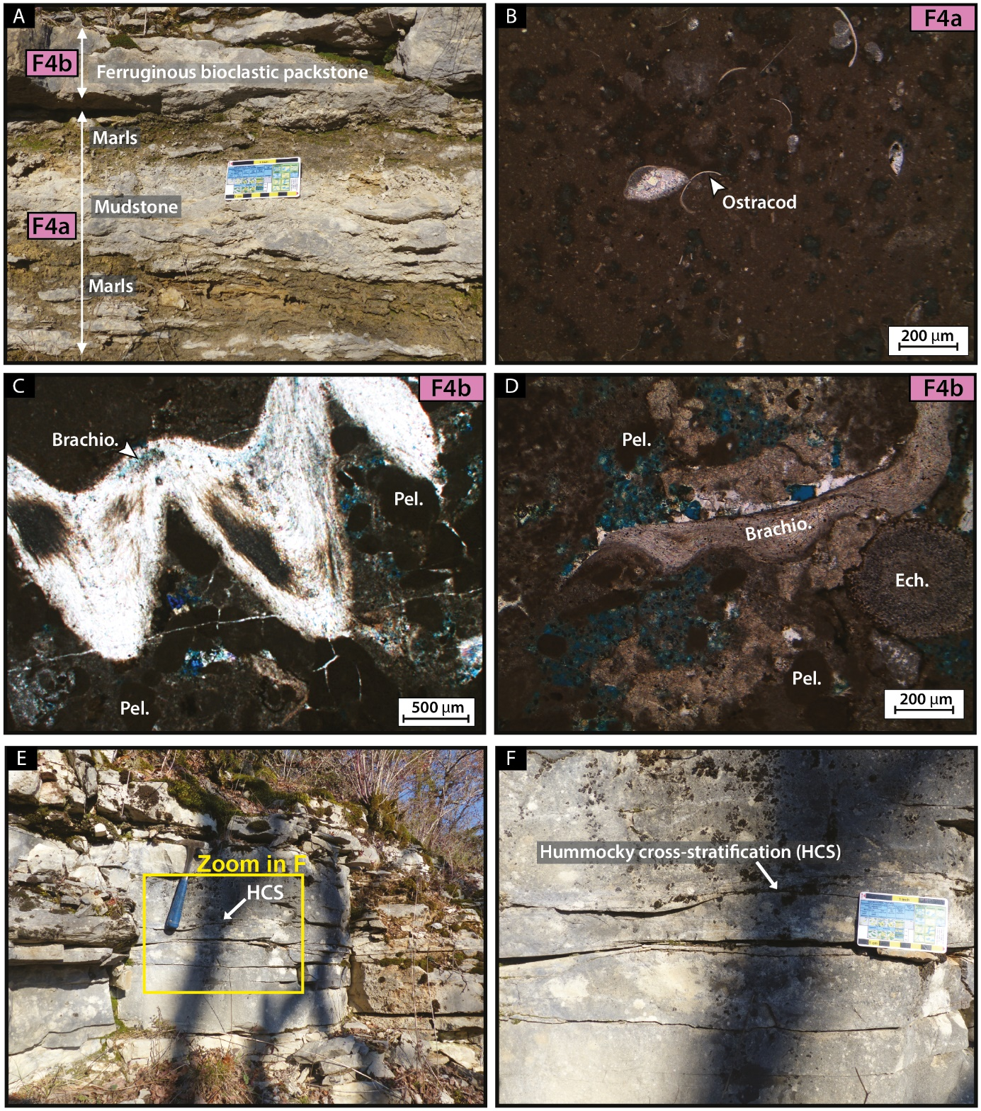

Figure S3: Field photographs and thin sections of deep subtidal lagoon environment (facies association FA4) coming from La Bouye outcrop (#14); Cajarc Formation. (A) Photograph of marls and carbonate mudstone alternations and ferruginous bioclastic packstone; facies F4a and F4b. (B) Mudstone containing ostracods; facies F4a; sample BY21. (C) and (D) Ferruginous bioclastic wackestone to packstone displaying brachiopods (Brachio.), echinoderms and peloids; facies F4b; sample BY14. (E) and (F) Marls and limestones alternation revealing an erosive surface marking the base of a tempestite deposit; facies F4a and F4b.
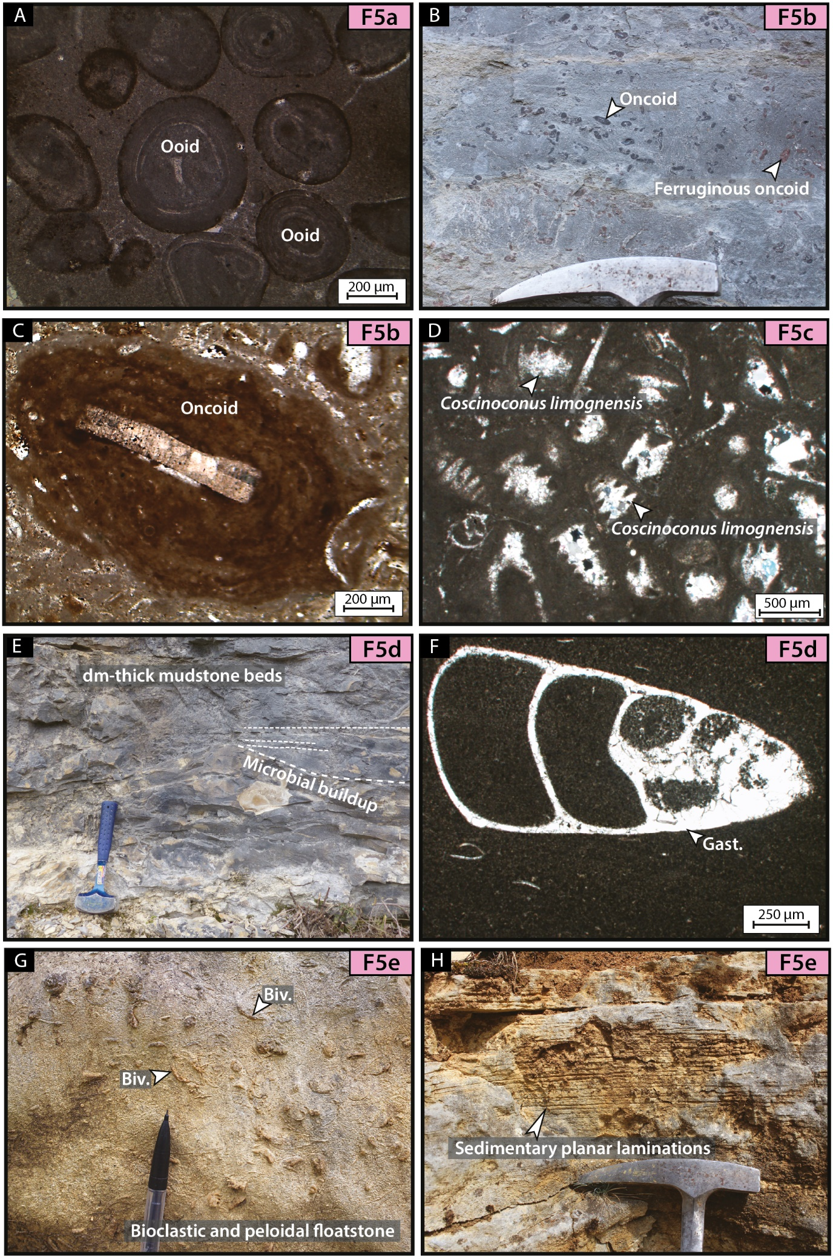
Figure S4: Photographs and thin sections of shallow subtidal lagoon environment (facies association FA5). (A) Ooid packstone; facies F5a; sample BZN12 ; Barrière de Beauzens outcrop (#41); Calcaire à oncolithes et stromatolithes de Beauzens Formation. (B) Field photograph of oncoidal floatstone with numerous oncoids and ferruginous oncoids; facies F5b; Bruniquel outcrop (#1); Autoire Formation. (C) Thin section of oncoid wackestone-packstone; facies F5b; sample AGB3; Bruniquel outcrop (#1); Autoire Formation. (D) Foraminifera packstone with abundant Coscinoconus limognensis; facies F5c; sample LZ1; Liauzu outcrop (#19); Rocamadour Formation. (E) Field photograph of dm-thick mudstone beds displaying carbonate microbial buildup (cauliflower form); facies F5d; Marcilhac-sur-Célé outcrop (#22); Cajarc Formation. (F) Thin section of mudstone with gastropods; facies F5d; sample BG1; Bourgnou outcrop (#30); Rocamadour Formation. (G) Photographs of bioclastic and peloidal floatstone with large bivalves, facies F5e; Rozier-Meynichou outcrop (#47); Calcaire à oncolithes et stromatolithes de Beauzens Formation. (H) Sedimentary planar laminations in bioclastic and peloidal wackestone; facies F5e; Rozier-Meynichou outcrop (#47); Calcaire à oncolithes et stromatolithes de Beauzens Formation.

  - Shallow subtidal lagoon (facies association FA5)
Description – The shallow subtidal lagoon (facies association FA5) includes five mud-dominated facies with well-preserved faunas. The facies F5a consists of ooid packstones (Figure S4A) showing local erosive basal surfaces (Faugeras, 1988), while facies F5b consists of irregular oncoid wackestone-packstone to floatstone facies (Figure S4B-C) associated with numerous bioturbations (Faugeras, 1988). Other facies are a foraminifera packstone (F5c; Figure S4D), tabular cm to dm-thick beds of mudstone (F5d; Figure S4E-F) commonly displaying carbonate buildups (cauliflower structures) (Figure S4E) and well-expressed sedimentary planar laminations in bioclastic and peloidal wackestone to floatstone facies (F5e; Figure S4G-H).
Interpretations – The muddy textures and absence of high-energy sedimentary structures (except in facies F5a) indicate that these facies formed in a calm and protected environment, i.e., a shallow subtidal lagoon. In facies F5a, frequent ooids and erosive surfaces suggest a depositional environment close to the barrier/shoal environment disturbed by events of higher energy, i.e., storms in back shoal settings. The mud-dominated textures, the presence of irregular oncoids and the abundant bioturbations in facies F5b argue that this facies was deposited in a calm shallow-water environment. In facies F5c, F5d and F5e, the abundance of benthic foraminifera, well-preserved gastropods and bivalves, planar sedimentary laminations, fine-grain-sized fraction and micritization of bioclasts indicate a very low-energy and protected lagoonal environment.
  - Intertidal to supratidal lagoon (facies association FA6)
Description – The intertidal to supratidal lagoon association (facies association FA6) encompasses seven sedimentary facies. Facies F6a named “peloidal packstone to grainstone”, contains microbial buildups formed by wavy microbial laminae (Figure S5A), microbial micro-structure Cayeuxia sp. (Figure S5B) and birdseye structures (Figure S5C). Facies F6b corresponds to oncoidal grainstone to rudstone (Figure S5D-E). Microbially laminated mudstone-wackestone to bindstone facies (F6c) present mud-cracks, microbial domes, flat to wavy microbial crusts (Figure S5F). Facies F6d is a mudstone with silicified evaporitic nodules and anhydrite precursors (Figure S5G). The organic-rich marls and lignite facies (F6e) display organic matter deposits (Figure S6A) and lignites infilling metric-scale tidal channels (Figure S6B) containing scarce gyrogonites, ostracods (Dépêche, 1967) and freshwater algae Botryococcus (Kafa, 1988). Fossil roots affect underlying formations with brecciation of surrounding mudstones (Kafa, 1988). Dolomicrite facies (F6f; Figure S6C) show dolo-mudstone strata without any skeletal allochems and sometimes associated with recrystallized lenticular gypsum. Dissolution collapse breccia (F6g; Figure S6D-E) is characterized by m-thick beds, angular mm- to cm-scale dolomicrite clasts, early dolomite cements and occasional bioclasts.
Interpretations – The intertidal to supratidal lagoon groups together facies deposited in the most proximal part of the lagoon, very shallow and frequently subaerially exposed. In facies F6a and F6b, the presence of planar laminations, birdseyes (F6a; Figure S5C), grainstone to rudstone textures, miliolids and meniscus cements (F6b; Figure S5D-E) characterize a beach environment. The facies F6c and F6d are commonly associated with microkarstification, desiccation cracks, anhydrite precursors, microbial buildups forming flat and wavy crusts and laminated microfabrics (Figure S5F-G), which indicate an intertidal to supratidal arid environment (sabkha) (Vennin et al., 2021). The presence of an organic-rich layer, metric-scale tidal channel (Figure S6A-B), fossil roots and freshwater algae Botryococcus (Kafa, 1988) in the facies F6e indicate a humid calm vegetated brackish-water mangrove, near the coast, in the intertidal to supratidal domain. The dolomicrite facies (F6f; Figure S6C) is characteristic of high salinity in evaporitic conditions present in an arid supratidal environment. Facies F6g shows evidence of evaporite dissolution collapse breccia (Figure S6D-E) subjected to arid conditions, intense evaporation and scarce influx of marine water. This facies was formed in sabkha-like environment, in the supratidal domain.
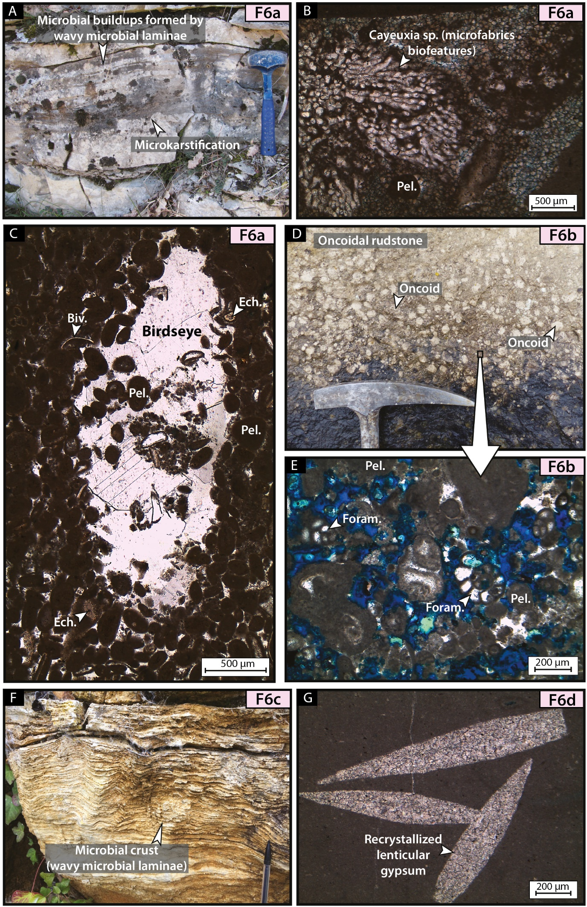
Figure S5: Photographs and thin sections of intertidal to supratidal lagoon environment (facies association FA6). (A) Field photograph showing microkarstification and microbial buildups formed by wavy microbial laminae (stromatolites) in a peloidal packstone to grainstone; facies F6a; La Bouye outcrop (#14); Cajarc Formation. (B) Peloidal packstone with microfabrics biofeatures Cayeuxia sp. and peloids; facies F6a; sample BY19; La Bouye outcrop (#14); Cajarc Formation. (C) Peloidal packstone to grainstone with peloids, bivalves and echinoderms; facies F6a; sample BY3; La Bouye outcrop (#14); Cajarc Formation. (D) and (E) oncoidal grainstone to rudstone with peloids and foraminifera; facies F6b; sample CPD3; Les Chauprades outcrop (#43); Calcaire oolithique et oncolithique du Seytier Formation. (F) Field photograph of wavy microbial buildups with laminated micrite microstructure; facies F6c; Saint-Martin-d’Albarède outcrop (#58), Calcaire oolithique de Lastours Formation. (G) Mudstone with recrystallized lenticular gypsum; facies F6d; sample BRG14; La Brégarié outcrop (#4); Cajarc Formation.

  - Paleosoil and palustrine (facies association FA7)
Description – The paleosoil and palustrine association (facies association FA7) consists of two facies: paleosoils (F7a; Figure S6F) and clayey mud-supported monogenic breccia (F7b; Figure S6G-H). Facies F7a is characterized by thin layers of micritic laminated crusts, micritic nodules/peloids (Figure S6F), a few gyrogonites and root traces (Pélissié, 1982; Kafa, 1988). This surface displays common mud-cracks and pebble breccia associated with the microkarstification process (Figure S6F). The clayey mud-supported monogenic breccia (F7b) consists of mud-supported, monogenic and decimeter-scale angular clasts embedded in a marly matrix (Figure S6G-H). This breccia contains reworked carbonate intraclasts (black pebbles) (Figure S6H). This facies only contains pulmonate gastropods, gyrogonites and ostracods (Pélissié, 1982).
Interpretations – The presence of micritic laminar calcretes, micritic nodules, gyrogonites and root traces in the facies F7a suggest a backshore or supratidal environment. Flat-pebble breccia associated with this facies indicate reworking of semi-consolidated microbial mudstones during intermittent high-energy pulses. This facies shows a shallowing-upward sequence, from nodular to laminar calcretes as described in Moreau et al. (2024) and is interpreted as having formed during subaerial exposure, probably corresponding to paleosoil. In facies F7b, the brecciated limestones (Figure S6G-H) and the presence of pulmonate gastropods and gyrogonites suggest a continental environment. In addition, the black pebbles are the result of reworked primary carbonate sediments, suggesting short transport in a palustrine environment (Miller et al., 2013). Alonso-Zarza and Wright (2010) interpreted similar facies as forming in palustrine systems close to the lake shoreline and subjected to lake-level variations, which imply successive drying and wetting periods in supratidal environments. The brecciation process, caused by periods of exposure which alternate with rewetting periods, form desiccation structures in these subaerial conditions during single or multiple events (Freytet, 1973; Freytet & Verrecchia, 2002).
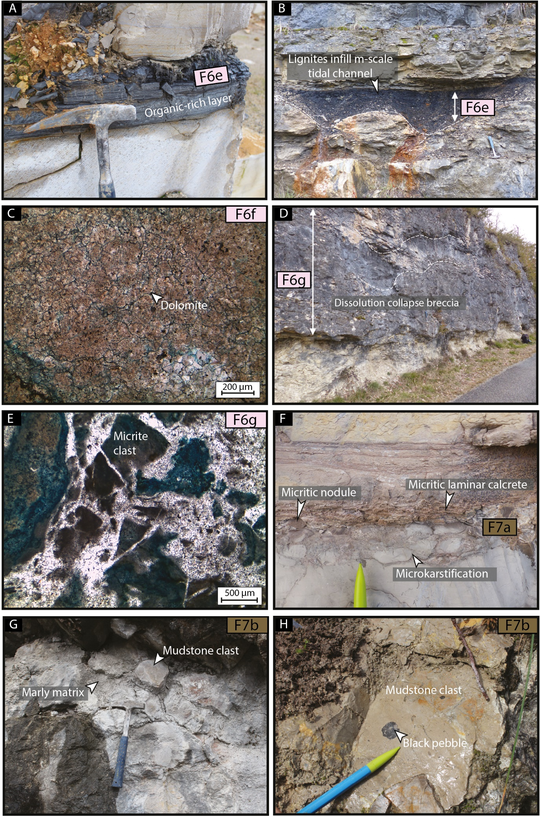
Figure S6: Field photographs and thin sections of intertidal to supratidal lagoon and continental environments (facies associations FA6 and FA7). (A). Organic-rich marls; facies F6e; Cénevières quarry (#11); Autoire Formation. (B) Metric-scale tidal channel filled with lignites; facies F6e; La Mounine outcrop (#16); Cajarc Formation. (C) Dolomicrite; facies F6f; sample BRG3; La Brégarié outcrop (#4); Cajarc Formation. (D) Outcrop of Saint-Chels (#17) showing evaporite dissolution breccia (collapse breccia); facies F6g; Cajarc Formation. (E) Thin section of collapse breccia displaying angular mm to cm-scale micritic clasts; facies F6g; sample SCL9; Saint-Cirq-Lapopie (#7); Cajarc Formation. (F) Paleosoil with micritic laminar calcretes, micritic nodules and pebble breccia associated with microkarstification; facies F7a; Saint-Martin-Labouval outcrop (#9); Cajarc Formation. (G) and (H) Photographs of clayey mud-supported monogenic breccia with marly matrix and black pebbles in mudstone clasts; facies F7b; Vers outcrop (#Q); Vers Formation.

- Stratigraphic architecture

2.1. Aalenian regressive hemicycle (sequences MJI to MJIII)
The Aalenian is composed of three depositional sequences: MJI, MJII and MJIII. This stage is marked by strong prograding dynamics. Facies indicate a gradual decrease in water depth in the eastern part of the study area (Figures 7 and 8) and lagoon/shoal environments progressed westward during the Middle and Late Aalenian (Figure 8). This Aalenian regressive trend is also observed further north in the Aquitaine and Paris basins (Andrieu et al., 2016). Aalenian deposits mark a condensed stratigraphic interval in Quercy, while they are absent in Périgord (Figure 7) (Bouilhac, 1987; Faugeras, 1988; Lézin, 2000). The thickness of the Aalenian deposits vary between 2 m and 20 m in Quercy (Figure 7), but increase westward, where thicknesses can reach 100 m in Arcachon and 90 m in Biscarrosse (Figure 8). The Aalenian, is characterized by a carbonate ramp geometry. The western part of the study area is occupied by upper to lower offshore environments, where marl/limestone alternations form (F1b, F2a and F2b; Figures 8 and 9A). Inner-ramp environments are limited to the far eastern portion of the study area (Figures 7 and 8).

During the Early Aalenian (sequence MJI), in the Quercy area from Brive-la-Gaillarde to Bruniquel (Figure 7), echinoderm-rich facies (transgressive system tract of sequence MJI; F2b) and packstones to grainstones with echinoderms and bivalves (regressive system tract of sequence MJI; F3a) formed in a homoclinal and storm-dominated ramp (Figure 7). During the Middle and Late Aalenian (sequences MJII and MJIII), marine regression led to the development of a shallow subtidal lagoon from Brive-la-Gaillarde to Bruniquel, where clayey oncoid wackestone to floatstone (F5b) formed (Figures 7, 8 and 9A). This lagoon is protected westward by a bioclastic-ooid shoal (F3b), roughly extending between Périgueux and Montauban (Figure 9A). The disappearance of ammonites and the occurrence of oncoids and green algae (Lézin et al., 2007) mark the disconnection from the open sea during the Early to Middle Aalenian (Alméras et al., 2013). During the latest Aalenian, limestones with calcites and quartz geodes (F6d) and dolomicrites (F7e) were deposited in a sabkha near Cahors (Figures 7 and 8).
The sequences MJI, MJII and MJIII are topped by sequence boundaries Aa1, Aa2 and Bj1, respectively. From Brive-la-Gaillarde to Bruniquel, surface Aa1 marks a change from shoreface to shallow subtidal lagoon facies, while Aa2 corresponds to a facies change from clayey oncoid floatstone (F5b) to peloids-rich packstone to grainstone (F6a) around Cahors (Figure 7). Surface Bj1 is a second order maximum regressive surface to subaerial unconformity that presents early karstification features from Cahors to Bruniquel (D10 discontinuity, Cubaynes et al., 1989; Figure 7).
2.2. Bajocian cycle (sequences MJIV to MJVII)
The Bajocian cycle is composed of four sequences: MJIV, MJV and MJVI and MJVII. The thickness of Bajocian deposits ranges between 70 m in Bruniquel, 190 m in Gramat and 90 m in Périgueux (Figure 7). It decreases westward with, for example, 5 m in Bordeaux (Figure S7) and 20 m in Langon (Figure 8). Inner-ramp environments cover the eastern part of the study area, passing westwards to a mid/outer-ramp setting where clayey bioclastic packstones (F2a and F2b; Figure 9B-C) and more rarely marls and marl/limestone alternations form (F1a and F1b; Figure 8). The carbonate ramp shows a long-term aggrading to prograding dynamicity throughout the Bajocian (Figures 7 and 8).
During the Early Bajocian, the increase of water depth led to the development of widespread oolitic shoals in the eastern part of the study area, which marks a second-order maximum flooding in the Humphriesianum zone (Figures 7 and 8). Facies are ooid grainstones (F3c), peloidal and superficial ooid grainstones (F3d) and oncoid-ooid grainstones to rudstones (F3e). Further north, near Brive-la-Gaillarde, oncoidal packstones (F5b) formed in a shallow subtidal lagoon (Figure 9B). A sharp regression occurred during the Late Bajocian Parkinsoni zone, leading to the shrinking of the ooid shoal facies (F3c) and the formation of intertidal to supratidal lagoon facies eastward (F6a and F6c; Figures 7, 8 and 9C). This abrupt relative sea-level fall is also documented in the Paris Basin (Andrieu et al., 2016).
Sequence boundaries Bj3, Bj4, and Bj5 top sequences MJV, MJVI, and MJVII, respectively. The surface Bj3 overlies oncolitic-rich facies (F5b) of shallow subtidal lagoon or ooid shoals (F3c) (Figure 7). The surface Bj4 is overlying organic-rich marls and lignites (F6e) and mudstone with silicified evaporite nodules (F6d) form the intertidal to supratidal lagoon (Figure 7), which marks a subaerial exposure. This latter surface also marks abrupt facies changes in Quercy and the Périgord regions from shoreface to intertidal to supratidal lagoon environments (Figure 7). The top of sequence MJVII (Bj5 surface) is characterized by microkarstification and mud-cracks near Cahors, and by the development of paleosoil facies around Périgueux (Figure 7). From Brive-la-Gaillarde to Bruniquel, Bj5 surface marks the transition from intertidal to supratidal to deep subtidal lagoon facies. Bj5 is interpreted as a second-order maximum regressive surface in the study area. This surface was already highlighted in previous works as a significative discontinuity (D13 discontinuity, Cubaynes et al., 1989). In the north-western Aquitaine Basin these surfaces are located on the top of limestone beds deposited in the upper offshore environment (Figure 8).
2.3. Bathonian cycle (sequences MJVIIIa to MJXI)
The Bathonian cycle contains five depositional sequences: MJVIIIa, MJVIIIb, MJIX, MJX and MJXI. The Bathonian deposits thickness varies between 70 and 175 m in the Quercy and Périgord regions (Figure 7), but significantly decrease westward, where it reaches 5 m in Bordeaux (Figure S7) and 15 m in Biscarrosse (Figure 8). During the Bathonian, a north-south oo-bioclastic to oolitic barrier (F3b and F3c), passing through Périgueux, Bergerac and Agen, marked the western limit of an extensive lagoon (Figure 9D-F). The Early Bathonian flooding led to the formation of a deep subtidal lagoon where storms affected sedimentation (F4a and F4b; Figure 9D). This marks the second order maximum flooding surface of the Bathonian cycle, located in the Aurigerus ammonite zone. This flooding is also identified to the north in the Paris Basin (Andrieu et al., 2016). During the Early to Late Bathonian, the shallowing-upward trend of the widespread deposition of lagoonal facies and the slow westward migration of inner-ramp environments indicate aggrading to prograding dynamics (Figures 7 and 8). Shallow subtidal lagoon environments with oncoidal and bioclastic facies (F5b, F5c and F5e) passed eastwards to a lagoon displaying intertidal to supratidal limestones (F6c and F6d) and sabkha limestones and breccia (F6g) (Figure 9E-F). The ramp dips westward to Bordeaux and Mont-de-Marsan where clayey bioclastic wackestone to packstone facies formed (F2a and F2b). Locally, to the north of Bordeaux, bioclastic clayey mudstones (F1b) infer deeper environments of the lower offshore (Figure 9D).
The sequences MJVIIIa, MJVIIIb, MJIX, MJX and MJXI are respectively topped by sequence boundaries Bt1a, Bt1b, Bt2, Bt3 and Bt4. From Périgueux to Bruniquel, surface Bt1a is a subaerial unconformity which is marked by channel-filled lignites (F6e) or a subaerial surface above a foreshore beach carbonate facies (F6a) (Figure 7). Bt1b is an exposure surface (F7a) from Souillac to Bruniquel (Figure 7). Surfaces Bt2 and Bt3 are located at the top of intertidal to supratidal lagoon environments from Souillac to Bruniquel (Figure 7). Bt4 overlies tidal-flat and paleosol horizons around Périgueux, and mudstone with anhydrite precursors (F6d) in Bruniquel (Figure 7) and marks a second-order subaerial unconformity. This surface was already highlighted in previous works as a significative discontinuity (D18 discontinuity, Cubaynes et al., 1989). Towards the basin center, all these surfaces correspond to marine discontinuities topping condensed carbonate layers, usually from upper offshore environments (Figure 8).

2.4. Callovian to Late Oxfordian transgressive hemicycle (sequences MJXII to LJVI)
The Callovian to Late Oxfordian is composed of eight depositional sequences: MJXII, MJXIII MJXIV, MJXV, LJI, LJII, LJV and LJVI (transgressive system tract only). This transgressive hemicycle is marked by aggrading architectures displaying facies belts located in similar positions throughout time (Figures 7 and 8). The thickness of the Callovian to Late Oxfordian hemicycle is quite homogeneous across the study area: 130 m in Quercy, 160 m in Périgord (Figures 7 and 8), 120 m in Bordeaux (Figure S7) and 130 m in Biscarrosse (Figure 8). During this time interval, the ramp shallowed eastward from lower/upper offshore to inner-ramp environments (Figures 8 and 9G). A shallow subtidal lagoon stretched from Brive-la-Gaillarde to Bruniquel (Figure 7), where oncoid wackestone-packstone to floatstone (F5b), foraminifera packstone (F5c) and massive azoic mudstones (F5d) formed (Figure 9G). This lagoon is rimmed westward by an oolitic barrier spreading from Périgueux to Agen and comprised of ooid grainstones (F3c) and oncoid-ooid grainstone to rudstone (F3e). Upper offshore environments prevailed around Mont-de-Marsan, where marl/limestone alternations formed (F2b), whereas lower offshore marls (F1a) and marl and clayey mudstone alternations (F1b) dominate near Bordeaux (Figure 9G). The brachiopod fauna described in Foucher (1986), 50 km north of the study area, indicate that the Early Callovian (i.e., sequences MJXII, MJXIII) is missing or condensed to a few meters. This is consistent with the large-scale correlations of Andrieu et al. (2016), showing that sequence MJXIV of the Middle Callovian directly overlies the Bathonian in this area. The occurrence of early karstification and geopetal silts at the top of the Bathonian indicate a subaerial exposure during the Early Callovian (Andrieu et al., 2017). Andrieu et al. (2016) sequence stratigraphy correlations also suggest that sequence MJXV of the Late Callovian is absent across a few tens of kilometers north of Périgueux. Sequences MJXII, MJXIII and MJXV could also be absent from the eastern part of our study area (Figures 7 and 8), which cannot yet be clearly demonstrated due to the lack of precise biostratigraphic markers. In the western part of the study area, ammonite biostratigraphy however shows the presence of Early Callovian, from Montendre (Figure S7). Facies are predominantly composed of upper offshore clayey bioclastic wackestones (F2b), more rarely of lower offshore marls (F1a) and marl/clayey mudstone alternations (F1b) (Figure S8).
The sequences MJXII, MJXIII and MJXV are topped by maximum regressive surfaces Cal1, Cal2 and Cal4, which directly overlie upper offshore marine surfaces in the center and west of the northern Aquitaine Basin (Figure 8). Sequences MJXIV, LJI, LJII, and LJV are topped by Cal3, Ox1, Ox2 and Ox5 maximum regressive surfaces, respectively. These surfaces are located at the top of subtidal lagoon facies from Périgueux to Bruniquel (Figure 7). In the western part of the study area these surfaces correspond to marine surfaces within lower offshore clayey mudstones (F1a and F1b) and upper offshore bioclastic wackestone (F2b) (Figure 8). The Callovian to Late Oxfordian hemicycle is topped by a major flooding surface that marks the predominance of lower offshore environments in the western part of the study area (Figure 8) and shoreface environments in Périgord and Quercy (Figures 7, 8 and 9H). This maximum flooding surface is located in sequence LJVI and is dated from the lower part of the Late Oxfordian by ammonite fauna around Montendre. It may correspond to the Glosense biozone maximum flooding surface of Andrieu et al. (2016).
2.5. Late Oxfordian regressive hemicycle (LJVI and LJVII)
The Late Oxfordian regressive hemicycle is composed of the LJVI regressive system tract and LJVII depositional sequence. The continuity and duration of this regressive trend during the Kimmeridgian have not been studied here. Eastward, the sedimentary facies evolution indicates a change from shoreface to palustrine environments, which prograde westward (Figures 7 and 8). The thickness of the Late Oxfordian deposits varies between 70 m in Périgueux and 80 m in Cahors (Figures 7 and 8). Likewise, to the west, thicknesses range from 90 m in Arcachon to 120 m in Langon (Figure 8). This period marks a transition between carbonate ramp to steep rimmed-platform geometry (Figures 8 and 9I).
During the latest Oxfordian (regressive system tract of LJVII sequence), paleosoils (F7a) and monogenic breccia with a marly matrix (F7b) formed in wetlands covering Quercy and Périgord (Figure 9I). These facies pass westward into mudstones (F5d) and bivalve-rich mudstones (F5e) which developed in the shallow subtidal lagoon (Figures 7 and 9I) and to bioclastic-ooid packstone to grainstone (F3b) from the shoreface environment (Figure 9I). The depositional environment abruptly deepens toward Bordeaux and Mont-de-Marsan (Figure S9) where upper offshore bioclastic wackestone to packstone (F2a) to lower offshore marls (F1a) were deposited (Figure 9I).

The sequences LJVI and LJVII are topped by sequence boundaries Ox6 and Ox7. Surface Ox6 corresponds to a marine discontinuity located in the bioclastic shoal environment in Quercy and Périgord (Figures 7 and 8) and lower offshore in the center of the basin (Figure 8). The precise position of Ox6 remains questionable due to the lack of a distinct surface, however, is highlighted 50 km north of the Périgueux region by large-scale correlations (Andrieu et al., 2016). The surface Ox7 overlies palustrine deposits (F7a and F7b), which mark a subaerial unconformity (Figure 7). To the west, Ox7 corresponds to a marine surface overlying clayey mudstone deposited in an upper offshore environment (Figure 8).

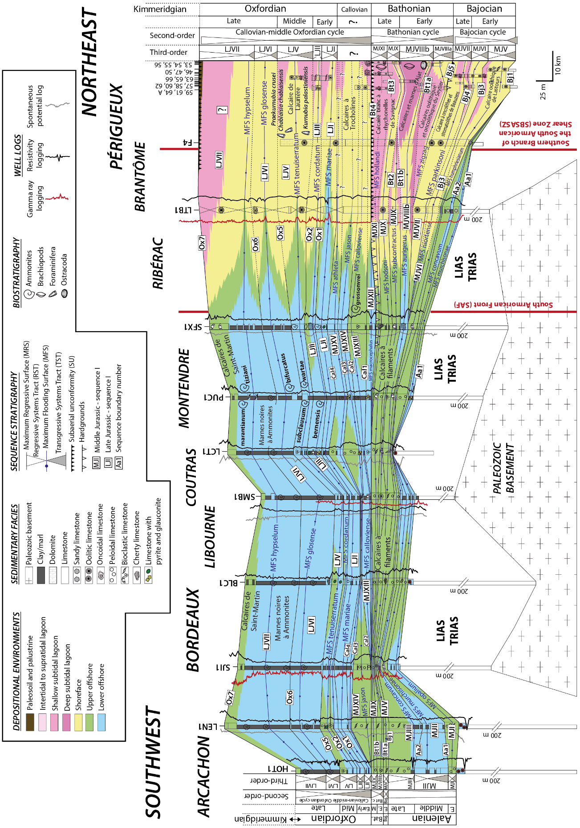
Figure S7: East-west cross-section from Périgueux to Arcachon, in the northern Aquitaine Basin, during the Aalenian to Oxfordian. This cross-section incorporates twenty-six sedimentary outcrops from the Périgord area and ten boreholes.

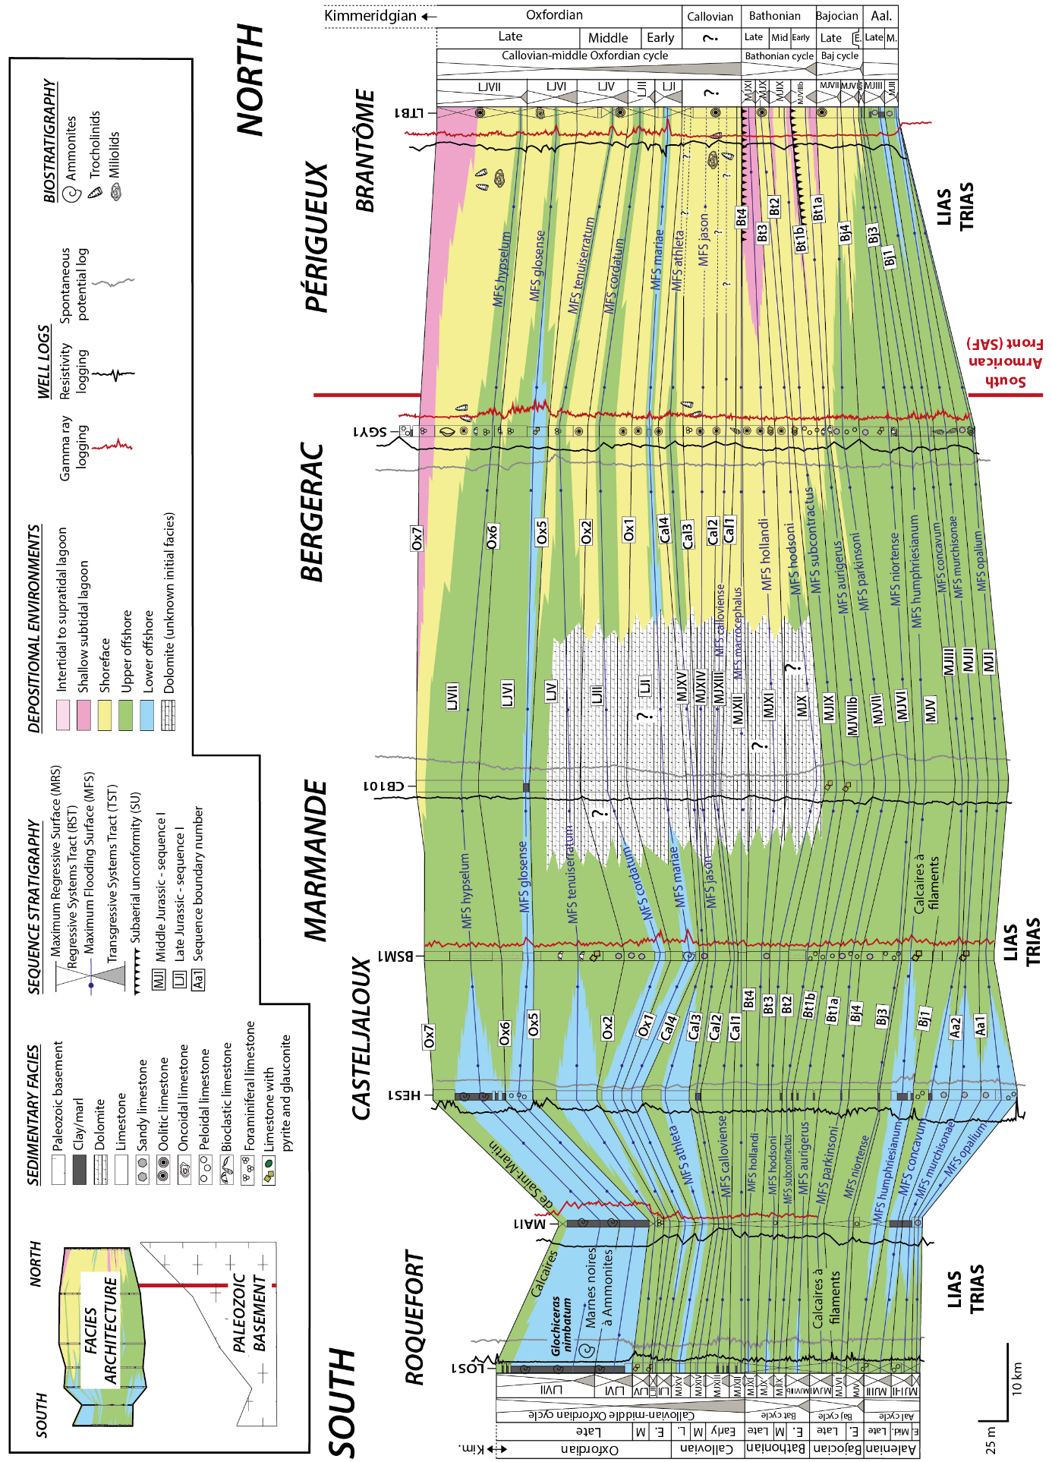
Figure S8: North-south cross-section of the northern Aquitaine Basin, during the Aalenian to Oxfordian. This cross-section integrates seven boreholes.

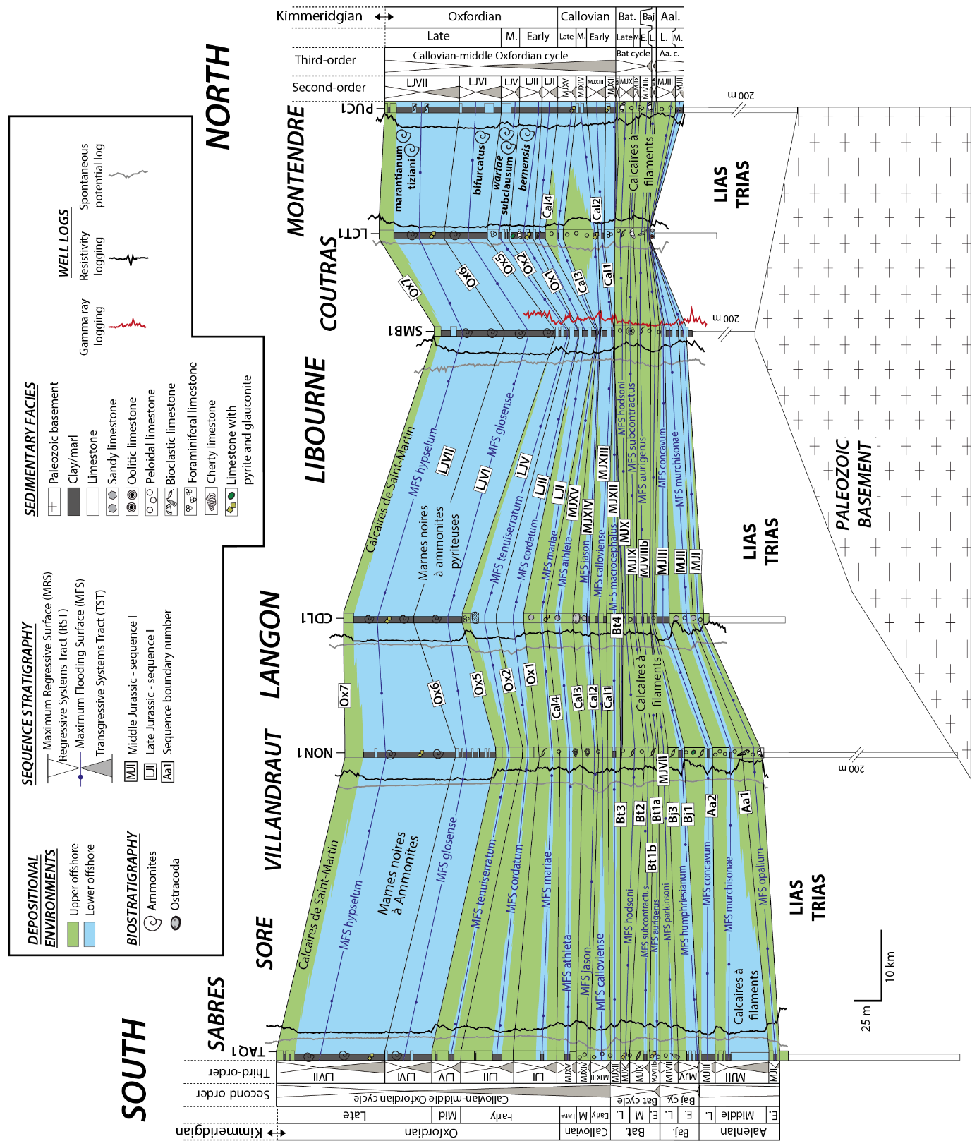
Figure S9: North-south cross-section of the northern Aquitaine Basin between Sabres and Montendre during the Aalenian to Oxfordian. This cross-section integrates six boreholes.

References

Alméras, Y., & Fauré, P. (2013). Brachiopodes du Lias et de l’Aalénien du Quercy (France). Paléontologie, biostratigraphie et paléoenvironnement. Échelles chronostratigraphiques. Strata (série 2), 47, 1–105.
Andrieu, S. (2016). Lien entre diagenèse des discontinuités, faciès sédimentaire et stratigraphie séquentielle : Exemple de la plateforme carbonatée de l’ouest de la France (Aalénien-Oxfordien) (Doctoral thesis, Université Paris-Saclay).
Andrieu, S., Brigaud, B., Barbarand, J., & Lasseur, E. (2017). Linking early diagenesis and sedimentary facies to sequence stratigraphy on a prograding oolitic wedge: The Bathonian of western France (Aquitaine Basin). Marine and Petroleum Geology, 81, 169–195. https://doi.org/10.1016/j.marpetgeo.2017.01.005
Alonso-Zarza, A. M., & Wright, V. P. (2010). palustrine carbonates. In A. M. Alonso-Zarza & L. H. Tanner (Eds.), Developments in Sedimentology, Carbonates in continental settings: facies, environments, and processes (Vol. 61, pp. 103–131). Elsevier. https://doi.org/10.1016/S0070-4571(09)06102-0
Bouilhac, M. (1987). Évolution sédimentaire et diagénétique des formations carbonatées du Bajocien du Périgord (Causses Cubjac et Martel) (Doctoral thesis, Université de Bordeaux).
Cubaynes, R., Fauré, P., Hantzpergue, P., Pélissié, T., & Rey, J. (1989). Le Jurassique du Quercy : unités lithostratigraphiques, stratigraphie et organisation séquentielle, évolution sédimentaire. Géologie de la France, 3, 33–62.
Dépêche, F. (1967). Etude stratigraphique et micropaléontologique du Jurassique inférieur et moyen des Causses du Quercy, région de Cajarc (Lot) (Doctoral thesis, Université de Paris).
Faugeras, P. (1988). Évolution de la plate-forme carbonatée est-aquitaine du Jurassique moyen en Périgord. Stratigraphie, sédimentologie, paléogéographie (Doctoral thesis, Université de Poitiers).
Freytet, P. (1973). Petrography and paleoenvironment of continental carbonate deposits with particular reference to the upper cretaceous and lower eocene of languedoc (Southern France). Sedimentary Geology, 10(1), 25–60. https://doi.org/10.1016/0037-0738(73)90009-2
Freytet, P., & Verrecchia, E. P. (2002). Lacustrine and palustrine carbonate petrography: an overview. Journal of Paleolimnology, 27, 221–237. https://doi.org/10.1023/A:1014263722766
Harder, H. (1980). Syntheses of Glauconite at Surface Temperatures. Clays and Clay Minerals, 28, 217–222. https://doi.org/10.1346/CCMN.1980.0280308
Kafa, J. (1988). Un modèle d’une plate-forme carbonatée, le Dogger inférieur du Quercy. Sédimentation – Diagenèse et évolution de la porosité (Doctoral thesis, Université de Pau).
Lézin, C. (2000). Analyses des faciès et stratigraphie intégrée : Application aux évènements du passage lias-dogger sur la plate-forme du Quercy. Doctoral thesis, Université de Toulouse 3. Strata, série 2, 35, 317p.
Lézin, C., Rey, J., Faure, P., Cubaynes, R., Pélissié, T., Durlet, C., & Deconinck, J.-F. (2007). Tectono-biosedimentary recordings at the Lias-Dogger transition: example of the Quercy carbonate platform (Aquitaine Basin, France). Bulletin de la Société Géologique de France, 178(4), 275–291. https://doi.org/10.2113/gssgfbull.178.4.275
Miller, C. R., James, N. P., & Kyser, T. K. (2013). Genesis of blackened limestone clasts at Late Cenozoic subaerial exposure surfaces, Southern Australia. Journal of Sedimentary Research, 83(4), 339–353. https://doi.org/10.2110/jsr.2013.32
Moreau, K., Andrieu, S., Briais, J., Brigaud, B., & Ader, M. (2024). Facies distribution and depositional cycles in lacustrine and palustrine carbonates: The Lutetian–Aquitanian record in the Paris Basin. The Depositional Record, 10(1), 124–158. https://doi.org/10.1002/dep2.264
Olivier, N., Carpentier, C., Martin-Garin, B., Lathuiliere, B., Gaillard, C., Ferry, S., Hantzpergue, P., & Geister, J. (2004). Coral-microbialite reefs in pure carbonate versus mixed carbonate-siliciclastic depositional environments: the example of the Pagny-sur-Meuse section (Upper Jurassic, northeastern France). Facies, 50(2), 229–255. https://doi.org/10.1007/s10347-004-0018-5
Pélissié, T. (1982). Le Causse Jurassique de Limogne-en-Quercy : stratigraphie, sédimentologie, structure. (Doctoral thesis, Université de Toulouse).

