Title in English
Title in French
First name LAST NAME ¹, First name LAST NAME ² and First name LAST NAME ^{3,}*

¹ Affiliation 1 ; ORCID 1 :
² Affiliation 2 ; ORCID 2 :
* Corresponding author: mailing address, xxxx@e-mail.com (indicate the email and mailing address of the corresponding author whether or not they are the first author of the article)

Title in English
Title in French

Abstract: A maximum 150-word paragraph giving a global overview on the article content. The abstract should be an objective representation of the article and should not contain results unincluded in the main text. Upon submission, the abstract and key words must be given in English and in French. They should be edited by native-speaking readers whenever possible.
Keywords: keyword 1 ; keyword 2 ; keyword 3… (list four to five relevant keywords that will best define the content of the text and are common to the field concerned.
Abstract in french : xx
Key words in french: xx

How to use this template to prepare your article
This template identifies the sections that can be used in your manuscript. Note that each section has a corresponding style, available in the Word "Styles" menu. The section headings are for empirical articles. Other contributions have a more flexible structure. For these, you may freely change the section and sub-section headings without changing the layout or the hierarchy of the headings and sub-headings in Styles. This template was designed in accordance with best practices of accessibility for the peoble with disabilities so it is important not to make any changes in style.

Articles soumitted to the « Dossier section » (empirical or theoretical articles or literature reviews) have a limit of 50,000 characters including spaces (including also summaries, tables, figures and references). Annexes are not counted.
You need to prepare two separate docx files: an anonymous one (without the Title page) and one that is complete.
Articles soumitted to « Open field section » have a limit of 30,000 characters including spaces (including also summaries, tables, figures and references). Annexes are not counted.
Delete this paragraph and start by Introduction
For any questions, please contact the editorial team at: RIHV@unige.ch ; dannyelle.valente@unige.ch

Introduction
The introduction should briefly place the study within a general context and highlight its importance. The aim of the work and its significance must be defined. The current state of the field of study need to be thoroughly reviewed and the main publications cited. Please highlight any controversial or divergent hypothèses. Finally, briefly mention the principal objective of the work and, if it is a research article, highlight your hypotheses. The introduction should be understandable for readers outside your field of work.
If subtitles are necessary here or elsewhere in your manuscript, they must respect the following style:

Sub-reading level 1

Sub-reading level 2

If you insert a list, use real lists with bullet points and numbers, as in the following examples :

- Text 1
- Text 2

Avoid a succession of words written in all caps. Reserve bold type for titles. For rich text, use italics only (Latin or foreign terms), never bold, underlined or capital letters (except at the start of a sentence, or for initials and proper nouns).
Every work cited must correspond to a precise bibliographical reference. In-text and end-of-text citations must follow APA 7th ed. guidelines.

Methods
This section should describe your study’s methodology in enough detail to allow others to reproduce the research under the same conditions. Novel methods and protocols need to be described in detail, whereas established methods can be briefly described and cited appropriately.
Authors must certify that research regarding human subjects is in line with the ethical principles of the World Medical Association Declaration of Helsinki.

Results
This section should offer a succinct, precise description of the data and results obtained

How to present figures and tables
All figures and tables need to be cited in the main text as Figure 1, Table 1, etc. All figures (images, diagrams) need to be accompanied by a description to make them accessible to blind people, as in the example below (Figure 1):

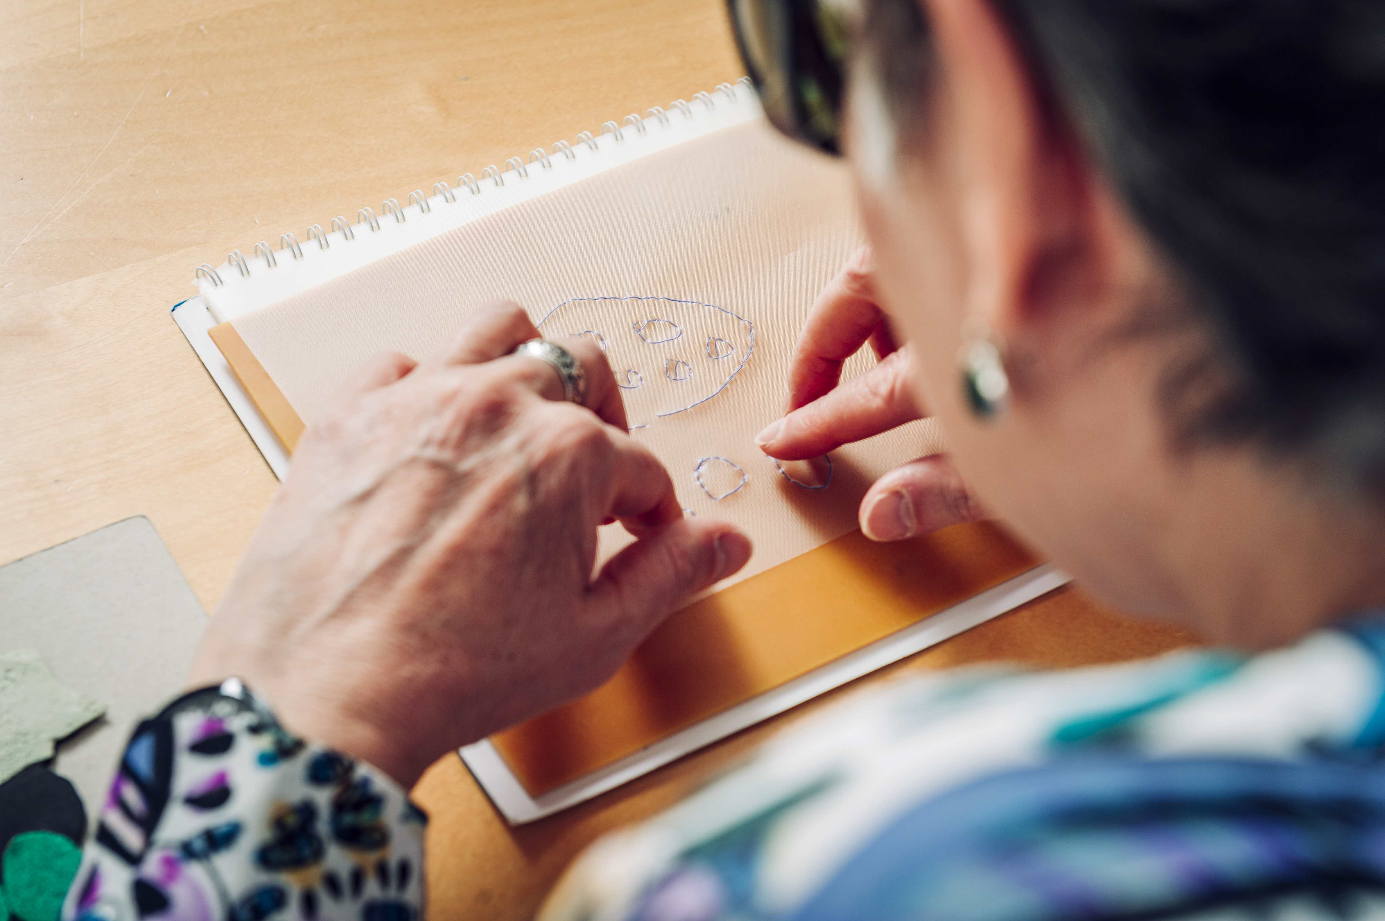
Figure 1. : A blind person testing a Tactilonary game prototype. Credit: Cyril FRESILLON / Dannyelle VALENTE / CNRS Images, https://images.cnrs.fr/en/photo/20220066_0021
Image description : Photograph of a blind person touching a drawing with contours in relief. On the right-hand side of the photo, we see the person’s profile. At the center, their two hands touch the relief drawing, which has been created on a DYCEM sketchbook. This non-figurative drawing is made up of small squares and circles.
Table 1. Place the table information here. The Information must be sufficiently clear and detailed that the reader can understand the table contents.
 | Title 1 | Title 2 | Title 3
Entry A | data | data | data
Entry B | data | data | data

When building your tables, take into account the rules on accessibility for persons with disabilities:
Tables should never be used to divide text into multiple columns. To achieve this in Word 2010, go to the ‘Layout’ tab and click ‘Columns’.
- If a data table is the best way to convey the information, use the following rules to assure that the table is accessible and comprehensible:
- Create a consistent table to enable readers to identify each cell and its meaning in the context;
- Give a title to the rows and columns;
- Avoid nesting tables and, to a lesser degree, merging or splitting cells;
- Do not include empty cells; if there is missing data, replace it with an explicit written reference;
- Do not use white lines or spaces to lighten the look of the table. Rather, use the formatting functions to create the space required; the Tab and Enter keys should be avoided;
- Do not include illustrations in a table;
- Offer a general or overall description of the table as a textual alternative and caption.

Discussion
In this section, the authors discuss their results and compare them to those of previous studies and to their working hypothèses. Practical implications and future research directions can also be highlighted.

Conclusion
This section is not required but can be added to the manuscript if the discussion is exceptionally long or complex.

Acknowledgements
In this section, you may mention any support given for the implementation of your study (participants, field partners, interns, consultants, etc.). If the research was financed, the names of the funding bodies and the grant number (where appropriate) should be cited here.

Appendix A
The appendix is an optional section. It can contain information complementary to the main text, (data, questionnaires, figures or explanations of the methods), which would have disturbed the flow but is still key to understanding and reproducing the study at hand. In the appendix, figures and tables need to be marked beginning with "A", for example, Figure A1, Figure A2, etc.
Figure A1

References
References are listed according to APA standards. All sources explicitly cited in the article must be included, and all references in the list must be cited in the text. If possible, include the DOI of each reference. We recommend preparing references using bibliography software, such as Zotero, EndNote, or ReferenceManager, to avoid typographical errors and duplicate references.

