Contribution Title
First Author¹ [0000-1111-2222-3333], Second Author² [1111-2222-3333-4444], Third Author³ [1111-2222-3333-4444]
¹ University of Geneva, Switzerland
² Priceton University, United State
Abstract. The abstract should summarize the contents of the paper in short terms, i.e. 150-250 words and use the abstract style.
Keywords: First Keyword, Second Keyword, Third Keywod, etc.
- Heading One - First Section
  - Heading two - A Subsection Sample
A normal paragraph: the article should be about 6000 words and use this template. Please note that the paragraph of a section or subsection is not indented. Links are allowed and use the hyperlink style.
A seconde paragraph start with 6pt space before.

Heading three
Only two levels of headings should be numbered. Lower level headings remain unnumbered;

Heading four
The contribution should contain no more than four levels of headings.
- Table
Table 1. Table captions should be placed above the tables.
Column heading 1 | Column heading 2 | Column heading 3
Column 1, line 1 | Column 2, line 1 | Column 3, line 1
Column 1, line 2 | Column 2, line 2 - Hightlighted | Column 3, line 2
Column 1, line 3 | Column 2, line3 | Column 3, line 3

- Figure
Please try to avoid rasterized images for line-art diagrams and schemas. Whenever possible, use vector graphics instead (see Fig. 1). Figures must be centered
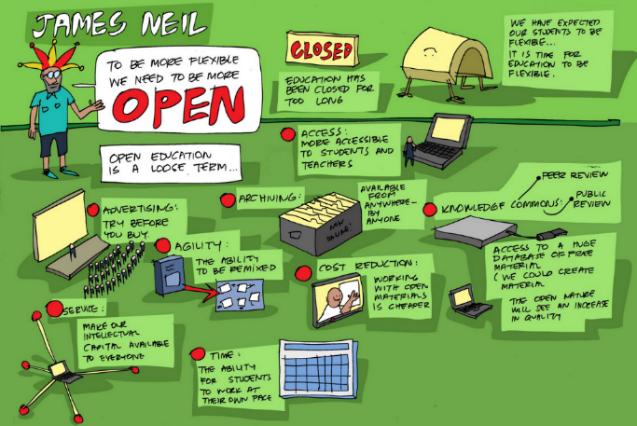
Fig. 1 A figure caption is explicit and placed below the illustration.
Image by Gavin Blake, in Openness and flexibility
- Reference
For citations of references, authors are free to use the reference system of their choice but are invited to use it consistently throughout the text. The following bibliography provides a sample reference list using the APA style.

Journal article: Author, F. (date). Article title. Journal 2(5), 99–110. https://doi.org/10.
Book chapter: Author, F. (date). Book chapter title. In Editor name, Book title (pp. 99-110). Publisher, Place published. https://doi.org/10.
Book: Author, F. (date). Book title. Publisher, Place published. https://doi.org/10.
Webpage: Author, F. (date if available). Web page title. Retrieved date from URL.
- Extended summary
Please make sure to provide a long abstract of about 1000 words in one of the 6 UN languages. Please visit https://oap.unige.ch/journals/eol-oe/information/authors for detailed information.
- Author self-declaration
Please make sure to provide author’s self-declaration information, either using the template or freely addressing positionality. Please visit https://oap.unige.ch/journals/eol-oe/information/authors for detailed information.

