Introduction
The polyhistidine tag (His tag) is a short peptide containing a series of histidines (2-10, but most commonly 6), extensively used for purification of tagged proteins using Ni2+-affinity chromatography (Hochuli et al., 1988). Anti-His antibodies, in addition, allow detection of the tagged protein using several immuno-analytical methods. Here, we show that the AD946 and AF371 recombinant antibodies detect a His-tagged human TAC protein by immunofluorescence in HeLa cells.

Materials &amp; Methods
Antibodies: ABCD_AD946 and ABCD_AF371 antibodies (ABCD nomenclature, http://web.expasy.org/abcd/; Lima et al., 2020) were produced by the Geneva Antibody Facility (http://unige.ch/medecine/antibodies/) as mini- antibodies with the antigen-binding scFv fused to a mouse IgG2A Fc. The synthesized scFv sequences (GeneArt, Invitrogen) correspond to the sequences of the variable regions of the clones 3D5 (for AD946, Lindner et al., 1997) and anti-His scFv (for AF371, Shimizu and Kajitani, 2011) joined by a peptide linker (GGGS)3. HEK293 suspension cells (growing in FreeStyleTM 293 Expression Medium, Gibco #12338) were transiently transfected with the vector coding for the scFv-Fc. Supernatants (40 mg/L for AF371) were collected after 4 days; AD946 has a low production yield in this system (<5 mg/L).
Antigen: HeLa cells (growing in DMEM GlutaMAXTM, Gibco #31966; supplemented with 8% Fetal Bovine Serum, Gibco #10270) cultured on glass coverslips (Menzel-Gläser, 22x22 mm) and transiently transfected 2 days before the experiment with a C-terminally 7xHis- tagged TAC protein (Uniprot #P01589), were used to detect the peptide tag. An antibody detecting the N- terminal extracellular domain of the TAC protein (AJ519, with rabbit IgG Fc; Arsimoles et al., 2020) was used as a positive control. The His-tagged TAC protein is expected to be mostly present at the cell surface.
Protocol: The whole procedure was carried out at room temperature. Transfected HeLa cells were rinsed once with PBS, fixed with PBS + 4% paraformaldehyde (w/v) (Applichem, #A3013) for 30 min, and blocked with PBS + 40 mM ammonium chloride (NH4Cl) (Applichem, #A3661) for 5 min. Cells were then permeabilized in PBS + 0.2% saponin (w/v) (Sigma, #S7900) for 3 min, incubated in PBS + 0.2% (w/v) BSA (PBS-BSA) for 30 min, and then with the tested anti-His antibodies (final concentration 5 mg/L in PBS-BSA) and AJ519 antibody (final concentration 2.5 mg/L in PBS-BSA) for 1 h. After 3 washes (10 min) with PBS-BSA, cells were incubated for 30 min in PBS-BSA with secondary goat anti-mouse IgG conjugated to AlexaFluor-647 and anti-rabbit IgG conjugated to AlexaFluor-488 (1:300, Molecular Probes, #A21235 and #A11034, respectively). After 3 washes (10 min) with PBS-BSA, cells were incubated during 10 min with DAPI (1:500, Molecular Probes, #D1306), washed twice with PBS-BSA and once with PBS, and mounted on slides (Menzel-Gläser, 76x26 mm) with Möwiol (Hoechst) + 2.5% (w/v) DABCO (Fluka, #33480). Pictures were taken using a Zeiss LSM700 confocal microscope, with a 63x Neofluar oil immersion objective.

Results
AD946 (despite its low production yield) and AF371 antibodies specifically detected a signal at the plasma membrane in cells transfected with the His-tagged TAC protein (Fig. 1). The signal co-localized with the signal generated by the anti-TAC AJ519 antibody (Fig. 1, arrows); the specificity of the signal was further verified by the absence of both anti-TAC and anti-His stainings in the few non-transfected cells (Fig. 1, arrowheads). No staining was observed when the primary antibody was omitted (Fig. 1, No Ab).

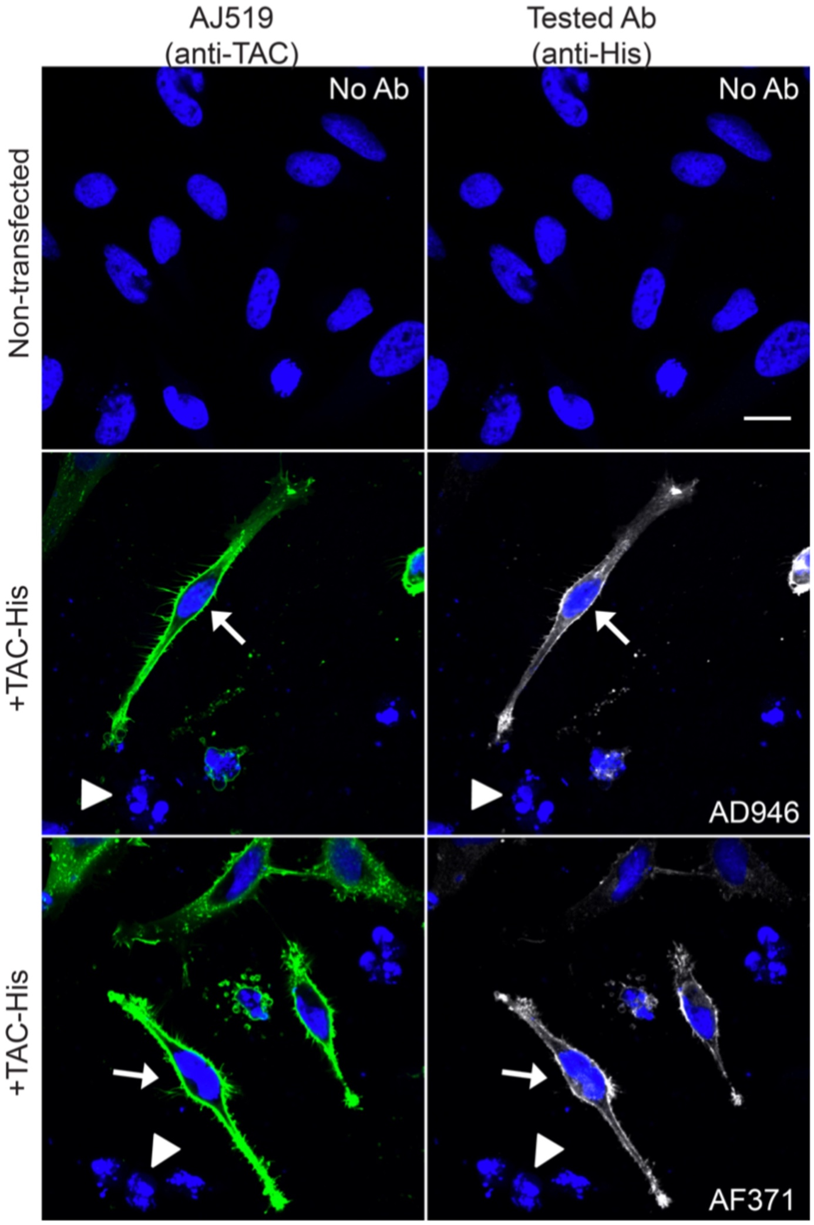
Figure 1. AD946 and AF371 labeled the plasma membrane of HeLa cells expressing the His-tagged TAC protein (in white); the signal co-localized (arrows) with the signal generated by the anti-TAC AJ519 antibody (in green); in blue, nuclei were stained with DAPI. No labelling was seen when the primary antibody was omitted, or in non-transfected cells (arrowheads). Scale bar: 20 μm.

Conflict of interest
Pierre Cosson and Wanessa Cristina Lima are editors of the Antibody Reports journal.

